# April 30, 2013

# The Roles of K+ Currents in Human Articular Chondrocyte Electrophysiology:

# A Computational Perspective

**Harish Narayanan\***  
*Center for Biomedical Computing,*   
Simula Research Laboratory, Oslo, Norway

**Mary M. Maleckar,**   
*Center for Biomedical Computing and Center for Cardiological Innovation,*   
Simula Research Laboratory, Oslo, Norway

**Robert B. Clark,**   
*Faculty of Kinesiology,*   
University of Calgary, Calgary, Canada

**James R. Wilson**

*Innovate Calgary Ltd.*

Calgary, Canada

**Wayne R. Giles,**   
*Faculty of Kinesiology,*   
University of Calgary, Calgary, Canada

*Corresponding author. Address: Center for Biomedical Computing, Simula Research Laboratory, P.O. Box 134, 1325 Lysaker, Norway Tel.:+47 4003-4801, Fax: +47 6782-8201

### Abstract:

This paper presents the first computational model of the main electrophysiological characteristics of the human chondrocyte. This model is illustrated by an *in silico* study of the TRPV4 current and is based mainly on an initial experimental data set which identified the main K+ currents expressed in single chondrocytes isolated from knee joints of healthy adult human donors. This model is validated by illustrating the role of a novel 2-pore K+ current in regulating the chondrocyte resting potential, and presents the possibility for integrating available data from electrophysiological, PCR and gene array experiments. It is also an important tool for rationalization of working hypotheses, design of new experiments, and understanding the principles and limitations of patch clamp methods as applied to the isolated human chondrocyte.

*Key words:* chondrocyte; electrophysiology; potassium currents; computational model

**INTRODUCTION**

Articular cartilage is considered to be an aneural, avascular, and alymphatic component of the flexible connective tissue that covers the articulating ends of diarthroidal joints (1-3). It is essential for the stability and low friction movement of the associated long bones. This connective tissue consists of an extracellular matrix (ECM, composed primarily of collagen, elastin and proteoglycans, (as detailed below) and is populated by only one type of cell - the chondrocyte. Articular cartilage is exposed to cyclical mechanical forces; in fact, this dynamic environment is essential for the health of the tissue (2). Chondrocytes occupy only approximately 1-10% of the total volume of articular cartilage in mammals ([4](chondrocyte-model.html#CarneyMuir1988),[5](chondrocyte-model.html#Halletal1996)). Chondrocyte play no direct mechanical role but are responsible for synthesis and homeostasis of the extracellular matrix. Mechanical support is provided by the ECM, which is composed of (a) collagen fibers that give the tissue the ability to resist tension, (b) negatively-charged gel-like proteoglycans (PGs) that are trapped within the collagen mesh and allow the tissue to bear compression (1,8) and (c) synovial fluid within the articular capsule which acts as a lubricant, thus ensuring low friction movement of the bones (7). The consensus view is that the primary role of the human chondrocyte is to maintain viable cartilage macromolecular synthesis and breakdown (see e.g. 2,7,9).

In a variety of conditions (including healthy aging), or as a consequence of injury, progressive chondrocyte damage and dysfunction may occur (10-12). In these situations, the balance between matrix synthesis and degradation is altered and the low friction environment within the joint may be reduced or lost (9). Under these conditions, there often is an inflammatory response within the articular joint. This is one factor that increases the early development of osteoarthritis: a thinning of the cartilage layer which causes painful, bone-against-bone friction (1,11). The progression of osteoarthritis (12,13) and the ability of chondrocytes to respond to perturbations in the extracellular environment (14) are associated with deficiencies in chondrocyte volume regulation (15). It is known that physical damage to cartilage is more frequent in the setting of altered osmolarity (16). In turn, there is evidence that these volume changes are linked to an abnormal resting membrane potential in chondrocytes (17), which may be due to changes in K+ and/or Cl- channel activity. Direct experimental investigations that address possible functional relationships between chondrocyte electrophysiology and pathophysiology are challenging due to the small cell size of the mature chondrocyte and the associated limitations of *in vitro* electrophysiological studies. In fact, it is not at all certain that conventional patch pipette methods (18,19) can accurately determine the resting potential of isolated single chondrocytes (20).

Accordingly, for the purposes of integrating available experimental data and attempting to understand its functional significance, we have developed a mathematical model of human chondrocyte electrophysiology. The main goals of this work are (i) to develop the first detailed mathematical model of chondrocyte electrophysiology and (ii) to illustrate the utility of the model in investigating the dependence of the chondrocyte resting membrane potential on identified voltage- and ligand-gated membrane currents.

**MODEL DEVELOPMENT AND METHODS**

The chondrocyte is known to express a number of voltage- and ligand-gated ion channels as well as ion-selective pumps and exchangers (30). Patch clamp experiments performed on enzymatically isolated individual human chondrocytes obtained from a knee replacement surgery program (The Southern Alberta Transplant Service) provided the experimental data for this model development. These chondrocytes had resting membrane potentials ranging from -30 to -60 mV when superfused with normal Tyrodes solution and then studied using antibiotic-permeablized (amphotericin) patch clamp methods (28). This significant range of resting membrane potential values may reflect the heterogeneous physiological state of these cells. However, as we have reported previously, some of this variability is likely to result from the fact that in these very small, approximately spherical cells (diameter, 7 microns; capacitance 10-15 pF) the patch pipette recording method is being applied very near its technical limitations (20). This is because, the input resistance of the target cell (chondrocyte) is very large (10-20 Gohms), and the maximum seal resistance between the surface membrane of the chondrocytes and the polished surface of the glass pipette is 5-15 Gohms. The consequence is that the actual chondrocyte membrane potential may be underestimated due to the current flow through the seal resistance, which in most circumstances results in an apparent depolarization. The Appendix of this manuscript describes the known biophysical principles which, when combined, regulate the ways in which the combination of patch pipette seal resistance and intrinsic input resistance result in apparent values for the resting potential in small cells such as the human chondrocyte.

The main objective of this model of human chondrocyte cells is to obtain insights into the ionic mechanisms that underlie the resting potential *in situ*. The raw data that forms the basis of this model was derived mainly from our previously published recordings of the K+ currents in human chondrocytes (28). However, our data from mouse (31) and canine chondrocytes (32) have also been incorporated where noted. Other elements summarized diagrammatically in Figure 1 below were obtained from published literature on isolated chondrocytes from rabbit, canine and equine tissue.

[Figure 1]

## The Atypical Environment of the Chondrocyte

The human chondrocyte is in a physiological environment that differs significantly from that of most other mammalian cells (as summarized in Table 1). Nevertheless, large transmembrane electrochemical gradients for Na+, K+ and Cl- are very similar to those in other mammalian tissue types. These gradients lead to the requirement for an ATP-dependent Na+/K+ pump mechanism (assumed to be electrogenic) in order to maintain ionic homeostasis. Note, however, that the extracellular fluid within the articular joint is hypertonic (approximately 320 mOsm vs. blood plasma which is approximately 280 mOsm). In addition, the extracellular pH of the synovial fluid that bathes the chondrocyte is somewhat acidic, pH 7.2 (8,24).

The fixed negative charges on proteoglycans that are immediately adjacent to the chondrocyte can attract free cations (e.g. Na+) and exclude free anions from the matrix. As a result of this cation accumulation (Table 1), there is an osmotically driven water influx to the cell. (10,17).

The articular joint receives little or no vascular supply. As a result, the synovial fluid must supply adult articular cartilage with the required small amounts of nutrients as well as oxygen to e.g., maintain Na+/K+ pump activity (33). Metabolic byproducts are removed mainly by diffusion (34,35). A second consequence of the avascular nature of this tissue is that chondrocytes generate ATP by substrate-level phosphorylation during anaerobic respiration. This generates H+ ions as a byproduct, which tends to lower the pH in this micro environment. The dynamic changes in mechanical loading within the knee joint during activity also exposes chondrocytes to very significant fluctuations in vector forces and shear. The resulting mechanical changes would be expected to activate mechano- or shear-sensitive ion channels (36-40).

**Table 1:** Consensus Values of Ion Concentrations in the Articular Joint.

|  |  |  |  |  |  |  |  |  |  |  |  |  |  |  |  |  |  |  |  |  |  |  |  |  |  |  |  |  |  |  |  |  |  |  |  |  |  |  |  |  |  |  |  |  |  |
| --- | --- | --- | --- | --- | --- | --- | --- | --- | --- | --- | --- | --- | --- | --- | --- | --- | --- | --- | --- | --- | --- | --- | --- | --- | --- | --- | --- | --- | --- | --- | --- | --- | --- | --- | --- | --- | --- | --- | --- | --- | --- | --- | --- | --- | --- |
| |  |  |  |  |  | | --- | --- | --- | --- | --- | | Electrolyte  Concentration (mM) | Cytoplasm | Matrix | Sinovial Fluid |  | | [Na+] | 40 | 240-350 | 140 |  | | [K+] | 120-140 | 7-12 | 5 |  | | [Ca2+] | 1-5 x 10-5 | 6-15 | 1.5 |  | | [Cl-] | 60-90 | 60-100 | 140 |  | | [HCO3-] | 20 | 15 | 23 |  | | [SO42-] | 0.17 | 0.30 | 0.81 |  | | pH (mM) | 7.1-7.2 | 6.6-6.9 | 7.4 |  | | Osmolarity (mOsm) | -- | 350-450 | 300 |  | |

Ref 8

**Membrane Currents**

### *Background Currents*

Three different time-independant background or leakage conductances, corresponding to resting Na+, K+, and Cl- fluxes, are included in this model using standard Hodgkin-Huxley equations:

|  |  |
| --- | --- |
|  | (1)  (2) |
|  |  |

The Nernst potentials for Na+ and K+ are computed based on their respective intra- and extracellular concentrations:

|  |  |
| --- | --- |
|  | (3)  (4) |

In mammalian chondrocytes from a number of different species, Cl- conductance have been identified (59,c.f. 30). This quasi-linear Cl- conductance has also been identified in human chondrocyte cell lines (61), in experiments in which selected transmitters or pharmacological agonists (e.g., histamine) have been applied (62). We have incorporated this type of Cl- current into our model by treating it as a background current, specified by the Hodgkin-Huxley expression in equation 5.

|  |  |
| --- | --- |
|  | (5) |

|  |  |
| --- | --- |
|  | (6) |

The current-voltage (IV) relationships for these sodium, potassium, and chloride background currents (INab, IKb, and IClb, respectively) are shown in Figure 2A.

### *Ion Pumps and Exchangers*

**Na+/K+ Pump**

The active (ATP requiring) extrusion of Na+ ions from the chondrocyte is assumed to be achieved by the turnover of an electrogenic Na+/K+-ATP pump. Mobasheri et al (33) have characterized some of the functional properties of an electrogenic Na+/K+ pump in bovine articular chondrocytes. In this model, we employ the sodium-potassium pump formulation from (42):

|  |  |
| --- | --- |
|  | (7) |

Where XX is XX...

Pump activity (density and turnover rate) has been scaled to achieve a steady-state intracellular Na+ concentration of 10-12 mM.

**Na+ /Ca2+ Exchanger**

As in many other cell types, the Na+/Ca2+ exchanger plays a key role in Ca2+ homeostasis in articular chondrocytes (41). We model this electrogenic exchange process using the following mathematical expression (42).

|  |  |
| --- | --- |
|  | (8) |

This ion exchange mechanism has been scaled based on an intracellular Na+ concentration of 12 mM, and an assumed [Ca2+] of 3 x 10-8 M.

**Na+ /H+ Exchanger**

Chondrocytes express a Na+/H+ antiporter (43,44), which contributes importantly to pH regulation. A pH gradient is essential for maintaining intracellular Na+ levels. Intracellular pH indirectly regulates a number of essential enzymatic processes in both physiological and pathophysiological settings.

To model this electroneutral antiporter, we have used the following expression (45):

|  |  |
| --- | --- |
|  | (9) |

where,

|  |  |
| --- | --- |
|  |  |

### Figure 2B shows I-V curve for these electrogenic pump and exchangers INaK and INaCa.

[Figure 2]

### *Potassium Currents*

Our model also incorporates mathematical expressions for a total of four distinct K+ currents. Each has been identified and characterized in electrophysiological studies of mammalian chondrocytes. Two of these, a time- and voltage dependent delayed rectifier K+ current, which we denote IK-DR, and a K+ current due to a 2-pore K+ channel, which we denote IK-2P, have been studied in detail in our laboratory (28,32) and also by other groups (45-57). The remaining two K+ currents, a Ca2+-activated K+ current (IK-Ca) and an ATP-dependent K+ current (IK-ATP) have been identified in patch clamp studies from other investigators (REF I).

**(a) Delayed Rectifier K+ Current: IK-DR**

A time- and voltage-dependent K+ current has been identified in the human articular chondrocyte (28-32). The biophysical properties of this current and the details of its pharmacological blockade suggest that it is generated by the family K+ conductances denoted Kv1.4 or Kv1.6. Accordingly, IK-DR is modeled by the following:

IKDR = gKDR • a • (V-VK) (10)

where a_dr is computed as part of the system using: ?

a_dr_inf   = 1.0/(1.0 + exp(-(V + 26.7)/4.1))

tau_a_dr   = 0.005/(1.0 + exp((V + 5.0)/12.0))

in our model.

Where XX is XX...

The two traces in Panel A of Figure 3 show (i) an experimental I-V relationship generated under physiological conditions, that is, a normal electrochemical gradient for K+and (ii) the corresponding model I-V curve. Figure 3B shows steady-state activation of this current, and Figure 3C illustrates the kinetics of activation.

[Figure 3]

**(b) 2-Pore K+ Current: IK2pore**

Our recent work has identified recording conditions under which an additional K+ current, generated by what is believed to be the TASK family of 2-pore K+ channels (28), can be identified (IK2pore). This K+ current exhibit no detectable time dependence. TASK channels show a significant increase in conductance in response to an increase in pH or alkalinization of the extracellular medium. A peak I-V curve for this current is shown in Panel A of Figure 4, while Figure 4B illustrates a significant enhancement of this current when extracellular pH was changed from XXXX.

These recordings were performed under conditions of increased [K+]o to ensure that these currents were relatively large, and that their biophysical properties could be resolved. However, before this data could be incorporated into this mathematical model, it needed to be corrected or scaled physiological conditions (normal [K+]o levels). This was done based on the Eisenman principle (54): the conductance of an ion-selective channel scales according to the square root of the extracellular concentration of the permeant ion. The I-V curve in Figure 4C shows the original data recorded in isotonic [K+](~145 mM), with the expected reversal potential of 0 mV, together with the corrected data (assuming [K+] to be 5.4 mM with a corresponding reversal potential of approximately -85 mV).

[Figure 4]

Using the classic Goldman-Hodgkin-Katz equation (54) for voltage-gated, time-independent single-species ion channels, this current can be represented by:

|  |  |
| --- | --- |
|  | (11) |
| Where XX is XX... |  |

Figure 5A shows the I-V curve fitted to experimental data (28) obtained in isotonic [K+]o conditions. In Panel B the corrected curve for an assumed normal [K+]o of 5.4 mM is shown. Our experimental work (REF) also demonstrated that this particular K+ current was strongly inhibited by bupivacaine; and that an effective concentration of bupivacaine also resulted in a significant depolarization of the resting potential (see Discussion).

[Figure 5]

**(c) Ca2+-Activated K+Current: IK,Ca-act**

Virtually all recordings of global K+ currents in human chondrocytes include a relatively large and very noisy outward current that is activated at depolarized potentials (55,56). The spontaneous fluctuations of this current suggest that it is generated by the so-called large conductance (often called BK) variant of the Ca2+ activated K+ current family (57). Our experimental work has not explored the biophysical properties of this current or its pharmacological profile in any detail. However, it is consistently present in our recordings. A Ca2+-activated K+ current (IK,Ca-act) has also been described in isolated chondrocytes from rabbits, dogs and horses (47). Thus, IK,Ca is included in the present model.

For the given data set (34), the (large) Ca2+-activated K+ channel can be represented by (57,58):

|  |  |
| --- | --- |
|  | (12) |

where,

|  |  |
| --- | --- |
|  |  |

Where XX is XX...

Figure 6 shows the I-V relationship for this current at a given [Ca2+]i.

[Figure 6]

**d) ATP-sensitive K+ Current: IK,ATP**

An ATP-sensitive K+ current has been identified in chondrocytes from a variety of mammalian species (59). Previous experimental work in human articular chondrocytes (34) did not reveal any significant IK,ATP, which is consistent with previous literature in human chondrocytes. However, the hypoxic environment of the articular chondrocyte makes the presence and the activation of this current during normal biomechanical activity plausible. Thus, this current (IK,ATP) is included in the present model. An I-V curve is shown in Figure 7:

IK,ATP = sigma*g_0*p_0*f_ATP*(V - E_K) (15)

Where XX is XX...

[Figure 7]

**Transient Receptor Potential or TRP Current: ITRPV4**

Ligand-gated channels that exhibit properties similar to the transient receptor potential or TRP family of ion channels are expressed in mammalian chondrocytes (63). In the absence of primary data from human chondrocytes this I-V relationship has been fitted to our data from a mouse chondrocyte cell line. TRPV4 is prominently expressed in mouse chondrocytes (64,65). It is likely that this type of conductance is the basis for the chondrocyte electrophysiological responses to naturally occurring paracrine substances (e.g., ATP) or to cytokines that are liberated in the setting of acute or chronic inflammation (e.g., XX). A further reason for incorporating this type of conductance into our initial model is that it exhibits significant permeability to both Na+ and Ca2+ (68). Either or both of these cation species are likely to be important in regulating excitation-secretion coupling. Na+ flux through TRPV4 channels could also modulate cell volume. It is also known that this type of ion channel can couple to purinergic receptors and/or to specific connexin proteins which function in the context of intercellular electrotonic communication, or as hemi-channels (REF). For these reasons, the TRPV4 ligand-gated ion channel has been incorporated into this initial model of the human chondrocyte as ITRPV4. An I-V curve is shown in Figure 8.

[Figure 8]

|  |  |
| --- | --- |
|  | (13) |
|  |  |

Where XX is XX...

***Intracellular Ca2+ Homeostasis***

The chondrocyte’s intracellular Ca2+, [Ca2+]i, is maintained by the sodium calcium exchanger (eq. 8), a sarcolemmal electroneutral Ca2+ ATPase (eq. 12) and in the presence of substantial intracellular buffering (eq. 13 and 14). In the absence of any data from the human chondocyte, the intracellular Ca2+ buffering in the present model is attributed mainly to calmodulin within the cytosol and is represented as in our previous models of the atrial myocyte (42,48).

I_Ca_ATP = I_Ca_ATP_bar*(Ca_i/(Ca_i + k_Ca_ATP)) (12)

dO_c/dt = 200,000*Ca_i*(1.0 – O_c) - 476.0*O_c (13)

dCa_i/dt = (I_NaCa - I_Ca_ATP)/(vol_i*F) - 0.045* dO_c/dt (14)

Where XX is XX...

## Model Implementation and numerical notes

In this first-order model, spatial variations in quantities of interest, that is restricted diffusion and/or extracellular ion accumulation, have not been accounted for. As a result, the human articular chondrocyte can be modeled by the following set of ordinary differential equations (ODEs) in time:

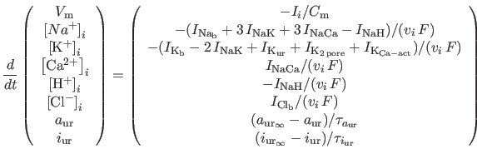 (15)

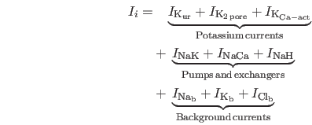

Where XX is XX...

The system of ordinary differential equations defined above was solved using LSODE (68). All initial conditions were chosen from previous calculations that were run to steady state. The corresponding GNU Octave code is available upon request freely and is open source.

1. All plots were generated with with a linear ramp in voltage from -130 mV to 90 mV in 1 s.

2. The cellular volume is fixed, but the concentrations are allowed to vary from their initial conditions.

3. The initial conditions were determined by not fixing the voltage and (repeatedly) allowing the cell to evolve to 10000 s, restarting the computation with the steady state solution as the initial condition until the system no longer evolved.

4. The parameters for all calculations are available in <root_folder>/code/parameters.m

5. Special cases:

    i. To fit with the isotonic experimental data in Figure 5 A, K_o_0 was set to 140 mM and P_K was set to 3.1e-6 units.

   ii. To compute the TRPv4 currents (green curves) in Figure 9 A and B, enable_I_TRP1 was set to true. Further more, to determine the effect of stretch, g_TRP1 was multiplied by a factor of 3 for figure 9 B.

**RESULTS**

Figure 1 in the Model Development/Methods section is a diagram of the major ion channels and ion transporters that have been incorporated into the initial version of this mathematical model of the basic electrophysiology (resting membrane potential) of the human chondrocyte. It is important to recall that the human chondrocyte functions as an isolated cell. Significant biophysical parameters include average whole cell capacitance, approximately 22 pF, and input resistance in normal physiological saline at room temperature, 2-5 Gohms.

Figure 2 focuses on the major background or time-independent ion conductances (Panel A) and the ATP mediated electrogenic pump and exchanger mechanisms. All adult chondrocytes from a number of mammalian species show small but measureable time-independent or background Cl-, Na+, and K+ conductances. None of these ion transfer relationships have been characterized in detail in experimental studies. Accordingly, (in 2A) they are represented as ohmic or linear current-voltage (I-V) relationships, each crossing the axis at their respective Nernst or electrochemical equilibrium potentials for Na+ (top), K+ (middle), and Cl- (bottom). The three I-V relationships in 2B are scaled to the measured membrane capacitance of the human chondrocyte, while being taken from our previous models of human atrial myocytes. The top I-V relationship is for the electrogenic Na+/K+ pump, and the middle I-V relationship is that the Na+/Ca2+ exchanger (at an intracellular [Ca2+] of 10-8 M). The bottom panel shows the I-V relationship for the Na+/H+ ion exchanger. Note that the Na+/H+ ion exchanger is known to be electroneutral.

The results in Figure 3 illustrate the important functional parameters that describe the I-V relationship or ion transfer mechanism (Panel A) for the delayed rectifier K+ current, IK-DR. We have characterized the major biophysical properties of the current in both human and canine chondrocytes. The steady state voltage dependence for this current is shown in Panel B and the corresponding kinetic parameters are summarized in Panel C. Note that this K+ current is very small or negligible at membrane potentials negative to -50 mV. In contrast, it is a prominent outward current at membrane potentials positive to approximately -40 mV. As a consequence, IK-DR could in principle contribute to or stabilize a relatively depolarized resting membrane potential and it does provide a significant outward repolarizing current following transient or maintained depolarizing stimuli to the human articular chondrocyte.

Figure 4 shows a family of IK-DR current traces. These recordings, as outlined in detail in the Methods section, were obtained using conventional patch clamp recording methods with [Ca2+] buffered to approximately 10-8 M using EGTA in the recording pipette. Note that I-KDR shows prominent time and voltage dependent activation with little if any inactivation, even in response to prolonged and substantial depolarizations.

An interesting and novel feature of the human chondrocyte (apparently in distinction to chondrocytes of other mammalian species) is the expression of a two-pore K+ channel mediated current. In our experiments, this current was studied under specialized physiological recording conditions (isotonic [K+]o) that were chosen to enhance the probability of identifying this small outward current. The data in Figure 5A shows a quasi-linear I-V relationship recorded in isotonic [K+]o. Note that under these conditions this conductance is substantial in the entire physiological range of membrane potentials in the human chondrocyte. As described in detail in our original paper, its identity as a two-pore K+ conductance, in fact likely of the TASK-3 variety, was made based upon its enhancement in response to acidification of pH0 and its sensitivity to volatile local anaesthetics.

Although the data in Figure 5A do provide convincing evidence for the functional expression for a two-pore K+ current, they do not provide any significant information concerning its physiological role. This is because these recordings were obtained under superfusition with isotonic [K+]o. The data computational data shown in Panel B depict the same ion channel activation pattern, this time recorded in physiological saline in silico. Note that the I-V remains quasi-linear. As expected, the reversal potential is at approximately -80 mV, very close to the predicted electrochemical equilibrium potential of K+ under these recording conditions. These calculations suggest that this two-pore K+ conductance can indeed generate a small but significant outward current under physiological conditions in the human chondrocyte.

The human chondrocyte has a very large input resistance (see Discussion). The consequence is that even a very small net current can significantly alter resting membrane potential. In summary, this novel two-pore K+ channel appears to have properties such that it can be a major contributor to the resting potential and can also explain, at least in part, the known sensitivity of the chondrocyte membrane potential and intercellular Ca2+ homeostasis to alterations in extracellular pH and to responsiveness to volatile anesthetic compounds.

Perhaps the most consistent electrophysiological feature of the recordings that have been made from mammalian chondrocytes is that these cells exhibit a significant Ca2+ activated K+ current. It is now well known that the molecular correlates of Ca2+ activated K+ channels can be divided into three sub-groups based on a number of different characteristics, including: (1) the specific biophysical properties of the current (e.g. its voltage dependence), (2) their pharmacological properties (e.g. sensitivity to block by apamin or tetraethylammonium), or (3) the single channel conductance. In the case of human chondrocytes, as shown in the inset of Figure 7, the pronounced current fluctuations or noise strongly suggest the presence of the variant of Ca2+ activated K+ channels known as the large conductance subtype. The major properties of this current have been incorporated into a detailed mathematical model by Aldrich et al. (REF).

We have used this mathematical formalism to simulate the I-V relationship that is assumed to have been recorded from isolated human chondrocytes under conditions in which initially the composition of the pipette solution includes buffered [Ca2+]i values approximately 10-8 M. In this setting, this current is activated at only very positive potentials. However, as [Ca2+] rises, the current is activated at more negative potentials as shown in the computations (Figure 7C). From the data at hand, it is not possible to deduce with certainty what the physiological role of this Ca2+ activated K+ current in the human chondrocyte is likely to be. However, the biophysiological and pharmacological properties, which we have identified and been able to accurately model, would strongly suggest that IK-Ca is a major repolarizing current but does not contribute substantially to the resting potential. Perhaps the best evidence for this is based on the fact that the input resistance of that cell is very high. Under this circumstance, activation of a small number of these large Ca2+ activated K+ channels would give rise to a resting potential that would be characterized by significant fluctuations in membrane voltage as opposed to what is observed – a stable resting membrane potential consistent in the range of -40 mV.

It is acknowledged that a major physiological role of the mature chondrocyte is to synthesize and secrete both collagen and hyaluronan paracrine substances (e.g. ATP and growth factors) by both constitutive and regulated mechanisms. These essential physiological functions give rise to important questions regarding the major cellular mechanisms for transmembrane Ca2+ entry, intracellular Ca2+ homeostasis (release and buffering), and Ca2+ extrusion.

In the initial model, we have addressed one of these important functional questions as follows: We note that in most isolated mammalian chondrocyte preparations a net current mediated by ligand or voltage-activated TRP channels can be identified. In the case of both mouse and human chondrocytes, the predominant isoform appears to be TRPV4. This pH, stretch, and temperature sensitive current is carried by both Na+ and Ca2+ under physiological conditions. When activated, the small net Ca2+ influx is sufficient to trigger a much larger release of Ca2+ from intracellular stores (endoplasmic reticulum). We have preliminary electrophysiological and pharmacological data concerning TRP channel expression/function in the isolated chondrocyte from a mouse cell line and from canine articular joint. This experimental data (I-V curve) and a superimposed curve fit based on the mathematical model derived by equation (XX) is shown in Figure 8.

***Ligand-gated ion channels and chondrocyte resting membrane potential***

Simulation of the electrophysiological response following activation of ITRPV4 is shown in Figure 9A. The effect of this channel-mediated current on the human articular chondrocyte resting membrane potential can be deduced by adding this current to the steady-state I-V relation (blue trace); it is clear that activation of TRP channels results in a transient depolarization of the chondrocyte (green trace) of approximately +20mV. The effects of a mechanical-impulse-related increase in TRPV4 conductance is additionally shown in Figure 9B; it is apparently that the resting membrane potential of the chondrocyte is further depolarized by approximately +10mV.

**DISCUSSION**

***Resting Membrane Potential in the Human Chondrocyte***

This model represents an original, semi-quantitative tool that can be used in continuing multidisciplinary studies of electrophysiological and biophysical principles of the human articular chondrocyte. Our initial emphasis is on investigating the basis of the resting potential (Vrest), since our data set consists mainly of K+ current measurements in this non-excitable cell. Moreover, it is known that even very small changes in the resting membrane potential can strongly modulate factors that govern intracellular Ca2+ signaling and homeostatic mechanisms. There is also evidence that relatively small alterations in membrane potential can contribute to dynamic regulation of cell volume (REF). In addition, both the strength and duration of ligand-gated conductance changes are dependent upon membrane potential (Vrest) since this sets the electrochemical driving force(s) for the permeant ions.

The computations shown in Figures 2 through 9 do not fully explain the ionic basis for Vrest in the human chondrocyte. Rather, they serve to illustrate that a range of membrane potential values are to be expected in this cell type. The net outward current that sets the resting membrane potential at steady-state is very small (the algebraic sum of background conductances as well as currents due to the electrogenic Na+/K+ pump and Na+/Ca2+ exchanger). In many recording situations the leak current through the patch pipette seal resistance can influence (and could even dominate) the observed ‘Vrest' (see Appendix). In addition, spontaneous changes in this seal resistance can give the impression of an unstable resting potential in these or similar cells.

Nevertheless, this work provides a basis for determining the physiological roles of each isolated of the four single K+ currents that have been identified and characterized in human chondrocytes. It is evident from the computed I-V curves (Figure 3, 5, and 6) that any, or all of these currents could: i) significantly hyperpolarize the resting potential or ii) repolarize the chondrocyte after it had been depolarized by e.g., the effects of mechanical activity or by via a ligand-gated conductance.

It is interesting to note that TRPV4 channel activation (as illustrated in Figure 9) would result in a significant influx of Ca2+ and Na+ when the chondrocyte membrane potential is negative to approximately -40 mV. A TRP channel-induced depolarization would be transient, and likely limited in magnitude, eventually transformed into a repolarization by the voltage-dependent activation of the delayed rectifier K+ current, IK-DR. It follows that when activation of TRP channels results in a significant increase in intracellular Ca2+, the Ca2+-dependent K+ current, IK,Ca-act, will also be activated. These potassium currents hyperpolarize the chondrocyte membrane potential and this potential will be maintained until intracellular Ca2+ and/or Ca2+-dependent signaling mechanisms reset to “resting” values.

The physiologic milieu within the articular joint results in conditions under which some of these K+ currents may be modulated significantly. For example, the extracellular fluid is hypertonic. The effects of osmolarity on voltage gated K+ currents have been studied extensively. In brief, as a consequence of changes in surface charge, shielding alterations in superfusate tonicity can significantly shift the steady state gating of currents such as IK-DR. Experimental work (28) was performed under fixed isotonic conditions. The literature would suggest that an increase in osmotic strength would cause a shift in steady state gating to the right, in the depolarizing direction, by perhaps 5 mV. This biophysical correction suggests that IK-DR does not make any significant contribution to the resting potential. However, this alteration would position this current to initiate prompt repolarization following any transient depolarization (e.g. via TRPV4 activation), while also ensuring that the input resistance of the cell at the resting potential remained very high. This is a critical factor, since a minimum of ion transfer may be desirable in the relatively hypoxic milieu of the articular joint.

***Practical Applications of the Model***

**Injury and Healing in Athletes**

Early signs of osteoarthritis may develop even in young individuals following articular joint injury. This is thought to be due to a phenomenon denoted 'chondrolysis', a condition in which accelerated loss of articular cartilage occurs over a short time period (21-23). Several clinical studies have also documented that this significant pathophysiological response also can occur as a result of postoperative administration of bupivacaine, a local anesthetic. Experimental work has confirmed that bupivacaine can cause profound effects including chondrocyte death in both isolated cell experiments (24) and associated animal studies (25-28). However, the cellular and subcellular mechanisms responsible for this toxic response (characterized by increased apoptosis) are not completely understood. In this regard, it is interesting to note that a family of two-pore K+ channels that have been recently identified in human articular chondrocytes can be inhibited by bupivacaine (29). Bupivacaine-induced block of these and other (29) 2-pore K+ channels can result in a pronounced depolarization of the chondrocyte (ref). It is thus important to gain a detailed understanding of resting membrane potential, intracellular Ca2+ levels (that can regulate apoptosis) and cell volume which can modulate excitation-secretion coupling. Future work employing the present model and its descendants will shed light on the functional relationships between these actors.

**Connexin-Mediated Current Flow**

The chondrocyte from adult humans functions as an isolated cell. As a result, it may seem that consideration of connexin function is irrelevant. However, data from humans during early adolescence suggest that the growth plate of articular joints is characterized by small groups of directly opposed chondrocytes with expression of selected members of the connexin family being detectable using standard immunohistochemical approaches (66). Moreover, it is now known that even in the case of isolated adult cells, prominent ATP release can be observed (67). One plausible mechanism for this chemical or mechanical release is transient opening of HEMI channels due to expression of either pannexin or connexin subunits. For these reasons, our model incorporates a connexin-mediated conductance which, under physiological conditions is shut off (has a conductance value of 0 pS). However, the present model would be facile tool for future exploration of connexin-mediated current flow and its implications, as well as exploration of multi-cellular chondrocyte substrates as occurring in the human articular growth plate.

***Limitations and Model Summary***

We recognize that, at this stage, our model has significant limitations. These include:

a) Mathematical expressions that would allow rationalization of what has been termed 'the AM and FM modes of Ca2+ signaling', which will require consideration of intracellular Ca2+-dependent phosphorylation and dephosphorylation reactions and consideration of the Ca2+-dependence involved in transcriptional regulation of ion channel, antiporter and pump target molecules.

b) An improved understanding of and development of mathematical approaches that may account for the response of the chondrocyte to the ambient hypoxia within the articular joint. Initially this is likely to require formulation of equations for hypoxia-activated K+ channels.

c) Adaptation of published mathematical formulations for alteration of ion channel activity arising from cyclic biomechanical stretch or from transient changes in shear forces that impinge upon the chondrocyte.

Initially, this mathematical model of chondrocyte electrophysiology provides a reliable platform for integrating and evaluating recent experimental data. This first-order model also has proven utility for rationalizing and bringing together genomic data from microarray expression profiles and as part of ion channel/antiporter drug target initiatives. Iterations based on the semiquantitative approach made possible by this model can also be useful for designing new experiments that are aimed at revealing cellular mechanisms that govern and modulate excitation-secretion coupling, as suggested in the previous section. Finally, given that the chondrocyte is in a unique, but yet not completely defined microenvironment our model provides a basis for explaining: i) the known biophysical effects of alterations in ionic strength of synovial fluid on ion channel voltage-dependent gating (zeta potential effects), ii) one common approach in attempts to account for the effects of cyclic stretch on ion channels - strain dependent alterations in channel gating voltage dependence or kinetics (cf. XX), and iii) much needed approaches for detecting and determining the limitations of present patch clamp technology that can bias, if not dictate, resulting data sets and influence their interpretation.

ACKNOWLEDGEMENTS:

An Alberta Innovates - Health Solutions Scientist Award (WRG), an AI-HS Starter Grant, and Canadian Institutes of Health Research, supports experimental work in the Giles laboratory. We are grateful to the Southern Alberta Tissue Transplant Facility (Dr. R. Krawetz) for supply of human articular joint (knee) tissue. Ms. Colleen Kondo prepared the human chondrocyte cultures and was responsible for project management. Postdoctoral fellowship funding (HR) from Simula Research Laboratory, Oslo, Norway and the AI-HS is gratefully acknowledged. Glaxo Smith Kline Laboratories in Philadelphia, Pennsylvania supplied the mouse chondrocyte cell line that we used to generate the data in Figure 9. We thank Doctors Bart Volt and S. Kuna for their interest in this work.

CONFLICT OF INTEREST:

None of the authors have any conflict of interest items to declare.

# 

## References

1 Poole, C. A. 1997. Articular cartilage chondrons: form, function and failure. *J. Anat.* 191:1-13.

2 Muir, H. 1995. The chondrocyte, architect of cartilage. Biomechanics, structure, function and molecular biology of cartilage matrix macromolecules. *Bioessays* 17:1039-1048.

3 Huber M., S. Trattnig and F. lintner. 2000. Anatomy, biochemistry and physiology of articular cartilage. *Invest. Radiol,* 35:573-580.

4 Stockwell, R. A. 1991. Cartilage failure in osteoarthritis: Relevance of normal structure and function. A Review. *Clin. Anat.* 4:161-191.

5 Hall, A. C., E. R. Horwitz, and R. J. Wilkins, 1996. The cellular physiology of articular cartilage. *Exp. Physiol.* 81:535-545.

6 Carney, S. L., and H. Muir, 1988. The structure and function of cartilage proteoglycans.   
*Physiol. Rev.* 68:858-910.

7 Buckwalter, J. A., and H. J. Mankin, 1998. Articular cartilage: Tissue design and chondrocyte-matrix interactions. *Instr. Course Lect.* 47:477-486.

8 Edwards, J. C., L. S. Wilkinson, … A. A. Pitsillides, 1994. The formation of human synovial joint cavities: A possible role for hyaluronan and CD44 in altered interzone cohesion. *J. Anat.* 185:355-367.

9 Urban J.P., A.C. Hall and K.A. Gehl, 1993. Regulation of matrix synthesis rates by the ionic and osmotic environment of articular chondrycytes. *J. Cell. Physiol.* 154:262-270.

10 Wilkins, R. J., J. A. Browning, and J. C. Ellory. 2000. Surviving in a matrix: Membrane transport in articular chondrocytes. *J. Membrane Biol.* 177:95-108.

11 Fassbender, H. G., 1987. Role of chondrocytes in the development of osteoarthritis. *Am. J. Med.* 83:17-24.

12 Bush, P.G., J.S. Huntley, I.J. Brenkel, and A.C. Hall. 2003. The shape of things to come: chondrocytes and osteoarthritis. Clin. Invest. Med. 26(5):249–51.

13 Bush, P.G., and A.C. Hall. 2005. Passive osmotic properties of in situ human articular chondrocytes within non-degenerate and degenerate cartilage. *J. Cell. Physiol*. 204(1):309–19.

14 Jones, W.R., H.P. Ting-Beall, … F. Guilak. 1999. Alterations in the Young's modulus and volumetric properties of chondrocytes isolated from normal and osteoarthritic human cartilage. Journal of Biomechanics. 32(2):119–27.

15 Bush, P.G., P.D. Hodkinson, G.L. Hamilton, and A.C. Hall. 2005. Viability and volume of in situ bovine articular chondrocytes-changes following a single impact and effects of medium osmolarity. Osteoarthr. Cartil. 13(1):54–65.

16 Hopewell, B., and J.P. Urban, 2003. Adaptation of articular chondrocytes to changes in osmolality. *Biorheology* 40:73-77.

17 Lewis, R., K. E. Asplin, …, R. Barrett-Jolley, 2011. The role of the membrane potential in chondrocyte volume regulation. *J. Cell. Physiol.* 226:2979-2986.

18 Ince, C., E. van Bavel, and A.A. Verveen. 1986. Intracellular microelectrode measurements in small cells evaluated with the patch clamp technique. *Biophys. J.* 50:1203-1209.

19 Dubois, J. 2000. What is the true resting potential of small cells? *Gen. Physiol. Biophys.*  19:3-7.

20 Wilson, J.R., R.B. Clark, U. Banderali and W.R. Giles. 2011. Measurement of the membrane potential in small cells using patch clamp methods. *Channels* 5:530-537.

21 Busfield, B.T., and D.M. Romero. 2009. Pain Pump Use After Shoulder Arthroscopy As a Cause of Glenohumeral Chondrolysis. Arthroscopy Association of North America; 1:(6)647–52.

22 Bailie, D.S. and T.S. Ellenbecker. 2009. Severe chondrolysis after shoulder arthroscopy: A Case series. *J. Shoulder Elbow Surg.*  18:742-747.

23 Wiater, B.P., M.B. Neradilek … and F.A. Matsen. 2011. Risk factors for chondrolysis of the glenohumeral joint: a study of three hundred and seventy-five shoulder arthroscopic procedures in the practice of an individual community surgeon. *J. Bone Joint Surg. Am*. 93(7):615–25.

24 Gomoll, A.H., R.W. Kang, …B.J. Cole. 2006. Chondrolysis after continuous intra-articular bupivacaine infusion: An experimental model investigating chondrotoxicity in the rabbit shoulder. Arthroscopy: J. Arth. Rel. Surg. 22(8):813–919.

25 Chu, C. R., N. J. Izzo, N. E. Papas, and F. H. Fu, 2006. In vitro exposure to 0.5% bupivacaine is cytotoxic to bovine articular chondrocytes. *J. Arthroscopy* 22:693-699.

*26 Rapley, J.H., R.C. Beavis, F.A. Barber. 2009. Glenohumeral Chondrolysis After Shoulder Arthroscopy Associated With Continuous Bupivacaine Infusion. 25(12):1367–73.

27 Webb, S.T., and S. Ghosh. 2009. Intra-articular bupivacaine: potentially chondrotoxic? *Br. J. Anaes*. 102(4):439–41.

28 Clark, R. B., C. Kondo, and W. R. Giles, 2011. Two-pore K+ channels contribute to membrane potential of isolated human articular chondrocytes. *J. Physiol*. 589:5071-5089.

29 Punke, M.A., T. Licher, O. Pongs, and P. Friederich. 2003. Inhibition of human TREK-1 channels by bupivacaine. Anesth. Analg. 1:665–73.

30 Barrett-Jolley, R., R. Lewis, R. Fallman, and A. Mobasheri, 2010. The emerging chondrocyte channelome. *Front. Physiol.* 223:511-518.

31 Clark, R. B., N. Hatano, … and W. R. Giles, 2010. Voltage-gated K+ currents in mouse articular chondrocytes regulate membrane potential. *Channels* 4:179-191.

32 Wilson, J.R., N.A. Duncan, W.R. Giles and R.B. Clark. 2004. A voltage-dependent K+ current contributes to membrane potential of acutely isolated canine articular chondrocytes. *J. Physiol.* 557:93-104.

33 Mobasheri, A., R. J. Errington, S.  and J. P. Urban, 1997. Characterization of the Na+, K+-ATPase in isolated bovine articular chondrocytes; molecular evidence for multiple alpha and beta isoforms. *Cell Biol. Int.* 21:201-212.

34 Otte, P., 1991. Basic cell metabolism of articular cartilage. Manometric studies. *Z. Rheumatol.* 50:304-312.

35 Lee, R. B., and J. P. Urban, 1997. Evidence for a negative Pasteur effect in articular cartilage. *Biochem. J.* 321:95-102.

36 Mow, V. C., C. C. Wang, and C. T. Hung, 1999. The extracellular matrix, interstitial fluid and ions as a mechanical signal transducer in articular cartilage. *Osteoarthr. Cartil.* 7:41-58.

37 Urban, J. P., 1994. The chondrocyte: A cell under pressure. *Br. J. Rheumatol.* 33:901-908.

38 Hall, A.C., J.P. Urban, and K.A. Gehl, 1991. The effects of hydrostatic pressure on matrix synthesis in articular cartilage. *J. Orthop. Res.* 9:1-10.

39 Wilkins, R.J., J.A. Browning and J.P. Urban. 2000. Chondrocyte regulation by mechanical load. *Biorheology* 37:67-74.

40 Sah, R.L., Y.J. Kim, and J.D. Sandy. 1989. Biosynthetic response of cartilage explants to dynamic compression. *J. Orthop. Res.* 7:619-636.

41 Sánchez, J.C., T. Powell … R.H. Wilkins, 2006. Electrophysiological demonstration of Na+/Ca2+ exchange in bovine articular chondrocytes. *Biorheology* 43:83-94.

42 Nygren, A., C. Fiset, … W. R. Giles, 1998. Mathematical model of an adult human atrial cell: The role of K+ currents in repolarization. *Circ. Res.* 82:63-81.

43 Trujillo, E., D. Alvarez de la Rosa, …, P. Martin-Vasallo. 1999. Sodium transport systems in human chondrocytes. II Expression of ENaC, Na+/K+ /2Cl- cotransporter and Na+/H+ exchangers in healthy and arthritic chondrocytes. *Histol. Histopathol.* 14:1023-1031.

44 Cha, C. Y., C. Oka, …, A. Noma, 2009. A Model of Na+ /H+ exchanger and its central role in regulation of pH and Na+ in cardiac myocytes. *Biophys. J.* 97:2674-2683.

45 Walsh, K.B., S.D. Cannon, and R.E. Wuthier. 1992. Characterization of a delayed rectifier potassium current in chicken growth plate chondrocytes. *Am. J. Physiol.* 262:C1335-1340.

46 Mobasheri, A., T. C. Gent, … R. Barrett-Jolley, 2005. Quantitative analysis of voltage-gated potassium currents from primary equine (*Equus caballus*) and elephant (*Loxodonta africana*) articular chondrocytes. *Am. J. Physiol. Regul. Integr. Comp. Physiol.* 289:R172-R180.

47 Mobasheri A., R. Lewis …R. Barrett-Jolley. 2012. Potassium channels in articular chondrocytes. *Channels* 6: ePub ahead of print.

48 Maleckar, M. M., J. L. Greenstein, W. R. Giles, and N. A. Trayanova, 2009. K+ current changes account for the rate dependence of the action potential in the human atrial myocyte. *Am. J. Physiol Heart Circ. Physiol.* 297:1398-1410.

# 49 Goldstein, S.A.N., K.W. Wang, and M.H. Pausch. 1998. Sequence and function of the two P domain potassium channels: implications of an emerging super family. *J. Mol. Med.* 76:13-20.

# 50 Goldstein, S.A.N., D. Bockenhauer, and N. Zilberberg. 2001. Potassium leak channels and the KCNK family of two-P-domain subunits. *Nat. Rev. Neurosci*. 2:175-184.

# 51 Kindler, C.H., and C.S. Yost. 2005. Two-pore domain potassium channels: new sites of local anesthetic action and toxicity. *Reg. Anesth. Pain Med.* 30:260-274.

# 52 Patel, A.J., and E. Honoré. 2001. Properties and modulation of mammalian 2P domain K+ channels *Trends Neurosci*. 24:339-346.

# 53 Gestreau, C., D. Heitzmann, …, J. Barhanin. 2010. Task2 potassium channels set central respiratory CO2 and O2 sensitivity. *Proc. Natl. Acad. Sci. USA.* 107:2325-2330.

54 Hille, B. 2001. *Ion Channels of Excitable Membranes.* Sinauer Associates, Sunderland, MA. p.11.

55 Grandolfo, M., P. D’Andrea, …, F. Vittur. 1992. Calcium-activated potassium channels in chondrocytes. *Biochem. Biophys. Res. Commun.* 182:1429-1434.

56 Zuscik, M.J., T.E. Gunter, and R.N. Rosier. 1997. Characterization of voltage-sensitive calcium channels in growth plate chondrocytes. *Biochem. Biophys. Res. Comm.* 234:432-438.

57 Horrigan, F. T., and R. W. Aldrich, 2002. Coupling between voltage sensor activation, Ca2+ binding and channel opening in large conductance (BK) potassium channels. *J. Gen. Physiol.* 120:267-305.

# 58 Magleby, K.L. 2003. Gating mechanism of BK (Slo1) channels: so near, yet so far. *J. Gen. Physiol.* 121:81-96.

59 Mobasheri, A., T.C. Gent, …, R. Barrett-Jolley. 2007. Evidence for functional ATP-sensitive (KATP) potassium channels in human and equine articular chondrocytes.  *Osteoarthritis Cartilage* 15:1-8.

60 Tsuga K, N. Tohse, … H Yabu. 2002. Chloride conductance determining membrane potential of rabbit articular chondrocytes. *J Membrane Biol*. 185(1):75–81.

61. Funabashi, K., M. Fujii … and Y. Imizumi, 2010a. Contribution of chloride channel conductance to the regulation of resting membrane potential in chondrocytes. *J. Pharmacol. Sci.* 113:94-99.

62. Funabashi, K., S. Ohya, … and Y. Imaizumi. 2010b. Accelerated Ca2+ entry by membrane hyperpolarization due to Ca2+-activated K+ channel activation in response to histamine in chondrocytes. *Am. J. Physiol. Cell. Physiol.* 298:C786-C797.

# 63 Phan, M.N., H.A. Leddy, …, F. Guilak. 2009. Functional characterization of TRPV4 as an osmotically sensitive ion channel in porcine articular chondrocytes. *Arthritis Rheum*. 60:3028-3037.

64 Clark, A.L., B.J. Votta… F. Guilak. 2010. Chondroprotective role of the osmotically sensitive ion channel transient receptor potential vanilloid 4: age- and sex-dependent progression of osteoarthritis in TRPV 4-deficient mice. *Arthritis Rheum.* 62:2973-2983.

65 Han, S.K., W. Wouters, A. Clark and W. Herzog, 2012. Mechanically induced calcium signaling in chondrocytes in situ. *J. Orthop. Res.* 30:475-481.

66 Sáez, J.C., V.M. Berthoud… E.C. Beyer, 2003. Plasma membrane channels formed by connexins: Their regulation and functions. *Physiol. Rev.* 83:1359-1400.

67 Knight M.M., S.R. McGlashan, … C.A. Poole. 2009. Articular chondrocytes express connexin 43 hemichannels and P2 receptors - a putative mechanoreceptor complex involving the primary cilium? *J. Anat.* 214:275-283.

68 Radhakrishnan, K., and A. C. Hindmarsh, 1993. Description and use of LSODE, the Livermore solver for ordinary differential equations. Technical Report UCRL-ID-113855, Lawrence Livermore National Laboratory.

Additional References:

Urban, J.P.G., A.C. Hall, and K. Gehl. 1993. Regulation of matrix synthesis rates by the ionic and osmotic environment of articular chondrocytes. *J. Cell. Physiol.* 154:262-270.

Wright, M.O., K. Nishida, …, and D.M. Salter. 1997. Hyperpolarisation of cultured human chondrocytes following cyclical pressure-induced strain: evidence of a role for alpha 5 beta 1 integrin as a chondrocyte mechanoreceptor. *J. Orthop. Res.* 15:742-747.

Wright, M.O., R.A. Stockwell, and G. Nuki. 1992. Response of plasma membrane to applied hydrostatic pressure in chondrocytes and fibroblasts. *Connect. Tissue. Res.* 28:49-70.

## Wright, M., P. Jobanputra, and G. Nuki. 1969. Effects of intermittent pressure-induced strain on the electrophysiology of cultured human chondrocytes; evidence for the presence of stretch-activated ion channels. *Clin. Sci. (Lond)*. 90: 61-71.

**Chilton, L., S. Ohya, …, and W.R. Giles. 2005.** K+ currents regulate the resting membrane potential, proliferation, and contractile responses in ventricular fibroblasts and myofibroblasts. *Am. J. Physiol. Heart Circ. Physiol.* 288:H2931-H2939.

# **Funabayashi, K., S. Ohya, …, and Y. Imaizumi. 2009. Accelerated Ca2+ entry by membrane hyperpolarization due to Ca2+-activated K+ channel activation in response to histamine in chondrocytes*. Am J Physiol Cell Physiol* 2009 Dec 30. [Epub ahead of print].

Lin, Z., J. B. Fitzgerald, …, and M.H. Zheng. 2008. Gene expression profiles of human chondrocytes during passaged monolayer cultivation. *J. Orthop. Res*. 26:1230-1237.

Pusch, M. and E. Neher. 1988. Rates of diffusional exchange between small cells and a measuring patch pipette. *Pflugers Arch.* 411:204-211.

Blatt, M.R. and C.L. Slayman. 1983. KCl leakage from microelectrodes and its impact on the membrane parameters of a nonexcitable cell. *J. Membr. Biol*. 72:223-234.

Barrett-Jolley, R., R. Lewis, …, and A. Mobasheri. 2010. The emerging chondrocyte channelome. Front. Physiol. 1:135.

# Beckett, E.A., I. Han, …, and S.D. Koh. 2008. Functional and molecular identification of pH-sensitive K+ channels in murine urinary bladder smooth muscle. *B.J.U. Int.* 102:113-124.

# Chu, C.R., N.J. Izzo, …, and A. Logar. 2008. The *in vitro* effects of bupivacaine on articular chondrocytes. J. Bone Joint Surg. Br. 90:814-820.

Clark, R.B., N. Hatano, …, and W.R. Giles. 2010. Voltage-gated K+ currents in mouse articular chondrocytes regulate membrane potential. *Channels* 4:179-191.

Hougaard, C., F. Jørgensen, and E.K. Hoffmann. 2001. Modulation of the volume-sensitive K+ current in Ehrlich ascites tumour cells by pH. *Pflügers Arch.* 442:622-633.

# Lopes, C.M.B., P.G. Gallagher, …, and S.A.N. Goldstein. 2000. Proton block and voltage gating are potassium-dependent in the cardiac leak channel Kcnk3. *J. Biol. Chem.* 275:16969-16978.

# Mobasheri, A., C. Dart, and R. Barrett-Jolley. 2008. Potassium ion channels in articular chondrocytes. Putative roles in mechanotransduction, metabolic regulation and cell proliferation. In *Mechanosensitive Ion Channels*, ed. Kamkin A & Kiseleva I, pp. 157-178. Springer, Berlin.

# Mobasheri, A., R. Lewis, …, and R. Barrett-Jolley. 2010. Characterization of a stretch-activated potassium channel in chondrocytes. *J. Cell. Physiol.* 223:511-518.

Ponce, A. 2006. Expression of voltage dependent potassium currents in freshly dissociated rat articular chondrocytes. *Cell. Physiol. Biochem.* 18:35-46.

Wilkins, R.J., and A.C. Hall. 1995. Control of matrix synthesis in isolated bovine chondrocytes by extracellular and intracellular pH. *J. Cell. Physiol.* 164:474-481.

# Yellowley, C.E., C.R. Jacobs, and H.J. Donahue. 1997. Effects of fluid flow on intracellular calcium in bovine articular chondrocytes. *Am. J. Physiol. Cell. Physiol.* 42:C30- C36.

Walsh, K. B., S. D. Cannon, and R. E. Wuthier, 1992. Characterization of a delayed rectifier potassium current in chicken growth plate chondrocytes. *Am. J. Physiol.* 262:C1335-C1340.

Sugimoto, T., M. Yoshino, M. Nagao, S. Ishii, and H. Yabu, 1996. Voltage-gated ionic channels in cultured rabbit articular chondrocytes. *Comp. Biochem. Physiol.* 115C:223-232.

Long, K.J. and K.B. Walsh. 1994. A calcium-activated potassium channel in growth plate chondrocytes: regulation by protein kinase A. *Biochem. Biophys. Res. Comm.* 201:776-781.

Mobasheri, A., R. Mobasheri, …, and P. Martin-Vasallo. 1998. Ion transport in chondrocytes: membrane transporters involved in intracellular ion homeostasis and the regulation of cell volume, free [Ca2+] and pH. *Histo. Histopathol.* 13:893-910.

Mozrzymas, J.W., M. Martina, and F. Ruzzier. 1997. A large-conductance voltage-dependent potassium channel in cultured pig articular chondrocytes. *Pflugers Arch.* 433:413-427.

Neher E. 1992. Correction for liquid junction potentials in patch clamp experiments. in: *Methods in Enzymology 207 (Ion Channels)*, ed. Rudy B, Iverson LE, pp. 123-131. Academic Press, San Diego, CA.

Dart, C., and N. B. Standen, 1994. Hypoxia induces a potassium current in smooth muscle cells isolated from the porcine coronary artery. *J. Physiol.* 477:P85-P86.

Mason, M.J., A.K. Simpson, …, and H.P.C. Robinson. 2005. The interpretation of current clamp recordings in the cell-attached patch-clamp configuration. *Biophys. J.* 88:739-750.

Perkins, K.L. 2006. Cell-attached voltage-clamp and current-clamp recording and stimulation techniques in brain slice. *J. Neurosci. Methods* 154:1-18

Ince, C., P.C. Leijn…, and D.L. Ypey. 1984. Oscillatory hyperpolarizations and resting membrane potentials of mouse fibroblast and macrophage cell lines. *J. Physiol.* 352:625-635.

Adams, D.J. and M.A. Hill. 2004. Potassium channels and membrane potential in the modulation of intracellular calcium in vascular endothelial cells. *J. Crdiovasc. Electrophysiol.* 15:598-610.

Loutzenhiser R. 2006. Inward rectifier currents in pericytes. *Am. J. Physiol* 77:1165-1232.

Wiedema, A.F. D.S.J. Dixon, and S.M. Sims. 2000. Electrophysiological characterization of ion channels in osteoclasts isolated from human deciduous teeth. *Bone* 27:5-11.

Barry, P.H., and J. Lynch. 1991. Liquid junction potentials and small cell effects on patch-clamp analysis. *J. Membrane Biol.* 121:101-117.

Goto, K., N.M. Rummery …, and C.E. Hill. 2004. Attenuation of conducted vasodilation in rat mesenteric arteries during hypertension: role of inwardly rectifying potassium channels. *J. Physiol.* 561:215-231.

Jantzi, M.C., S.E. Brett…, and D.G. Welsh. 2006. Inward rectifying potassium channels facilitate cell-to-cell communication in hamster retractor muscle feed arteries. *Am. J. Physiol.* 291:H1319-H1328.

Smith, P.D., S.E. Brett…, et al. 2008. Kir channels function as electrical amplifiers in rat ventricular smooth muscle. *J. Physiol.* 586:1147-1160.

Sigworth, F. and K. Klemic. 2002. Patch clamp on a chip. *Biophys. J.*  82:2831-2832.

MacCannell, K.A., H. Bazzazi, …, and W.R. Giles. 2007. A mathematical model of electronic interactions between ventricular myocytes and fibroblasts. *Biophys. J.* 92:4121-4132.

Edelman, A., C.L. Thil, …, and S. Balsan. 1985. Vitamin D metabolite effects on membrane potential and potassium intracellular activity in rabbit cartilage. *Miner. Electrolyte Metab.* 11:97-105.

Hamill, O.P., A. Marty, and F.J. Sigworth. 1981. Improved patch-clamp techniques for high-resolution current recording from cells and cell-free membrane patches. *Pflugers Arch.* 391:85-100.

Guilak, F., R.A. Zell, and H.J. Donahue. 1999. Mechanically induced calcium waves in articular chondrocytes are inhibited by gadolinium and amiloride*. J. Orthop. Res.* 17:421-429.

D'Andrea, P., A. Calabrese… F. Vittur. 2000. Intercellular Ca2+ waves in mechanically stimulated articular chondrocytes. *Biorheology* 37:75-83.

Yellowley, C.E., C.R. Jacobs… and H.J. Donahue, 1997. Effects of fluid flow on intracellular calcium in bovine articular chondrocytes. *Am. J. Physiol.* 273:C30-C36.

Marinta, M., J.W. Mozrzymas, and F. Vittur. 1997. Membrane stretch activates a potassium channel in pig articular chondrocytes. *Biochim. Biophys. Acta.* 1329:205-210.

Mobasheri, A., S.D. Carter, …, M. Shakibaei. 2002. Integrins and stretch activated ion channels; Putative components of functional cell surface mechanoreceptors in articular chondrocytes. *Cell. Biol. Int.* 26:1-18.

Millward-Sadler, S.J., M.O. Wright, …, D.M. Salter. 2000. Altered electrophysiological responses to mechanical stimulation and abnormal signaling through a5b integrin in chondrocytes from osteoarthritic cartilage. *Osteoarthritis Cartilage* 8:272-278.

### Figure 1. An illustration of the ion-selective channels included in the mathematical model of the chondrocyte.

### Figure 2. Background & pump currents

### A. Background currents Na+, Ca2+, K+

### B. pump/exchanger currents

### C. Net current, A+B, measured slope resistance in range of 1-2 Gohms

### Figure 3. I_K-DR

### A. IV curve, peak

### B. Activation curve

### C. Kinetics

### Figure 4. I_K2pore (A, B, C, all experimental)

### A. peak IV

### B. peak IV with increased pH

### C. isotonic measurement data and "corrected" data

### 

### Figure 5. I_K2pore in computation and corrected experiment

### Figure 6. Ca2+ -activated K+ current, experimental and computed

### Figure 7. ATP-sensitive K+ current, computed only

### Figure 8. TRP4V channel, computed only

**Figure 9.** In Discussion; activation of TRPV4 influence on RMP

A. Cell IV-relation including computational TRPV4 and without + experimental

B. Stretch increases the conductance 3-fold

**Figure 1**

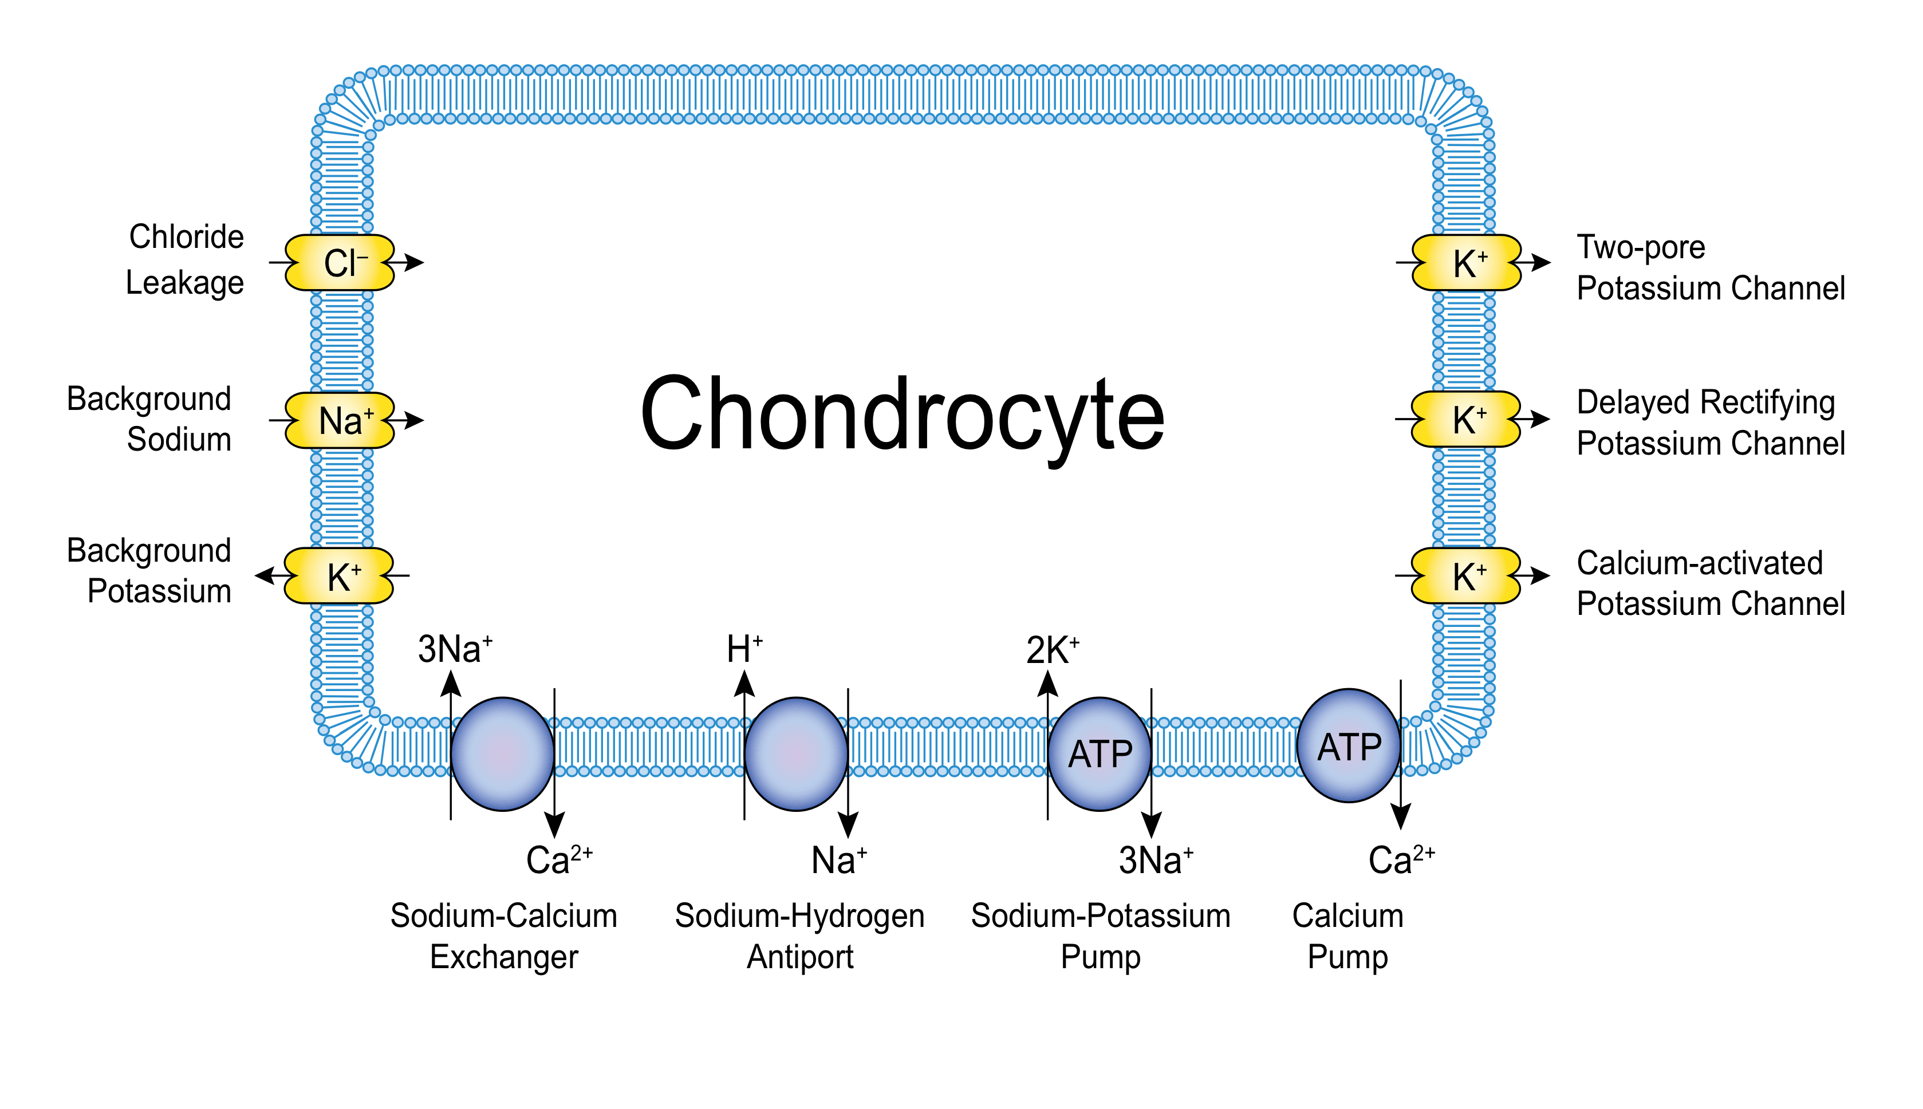**Figure 2**

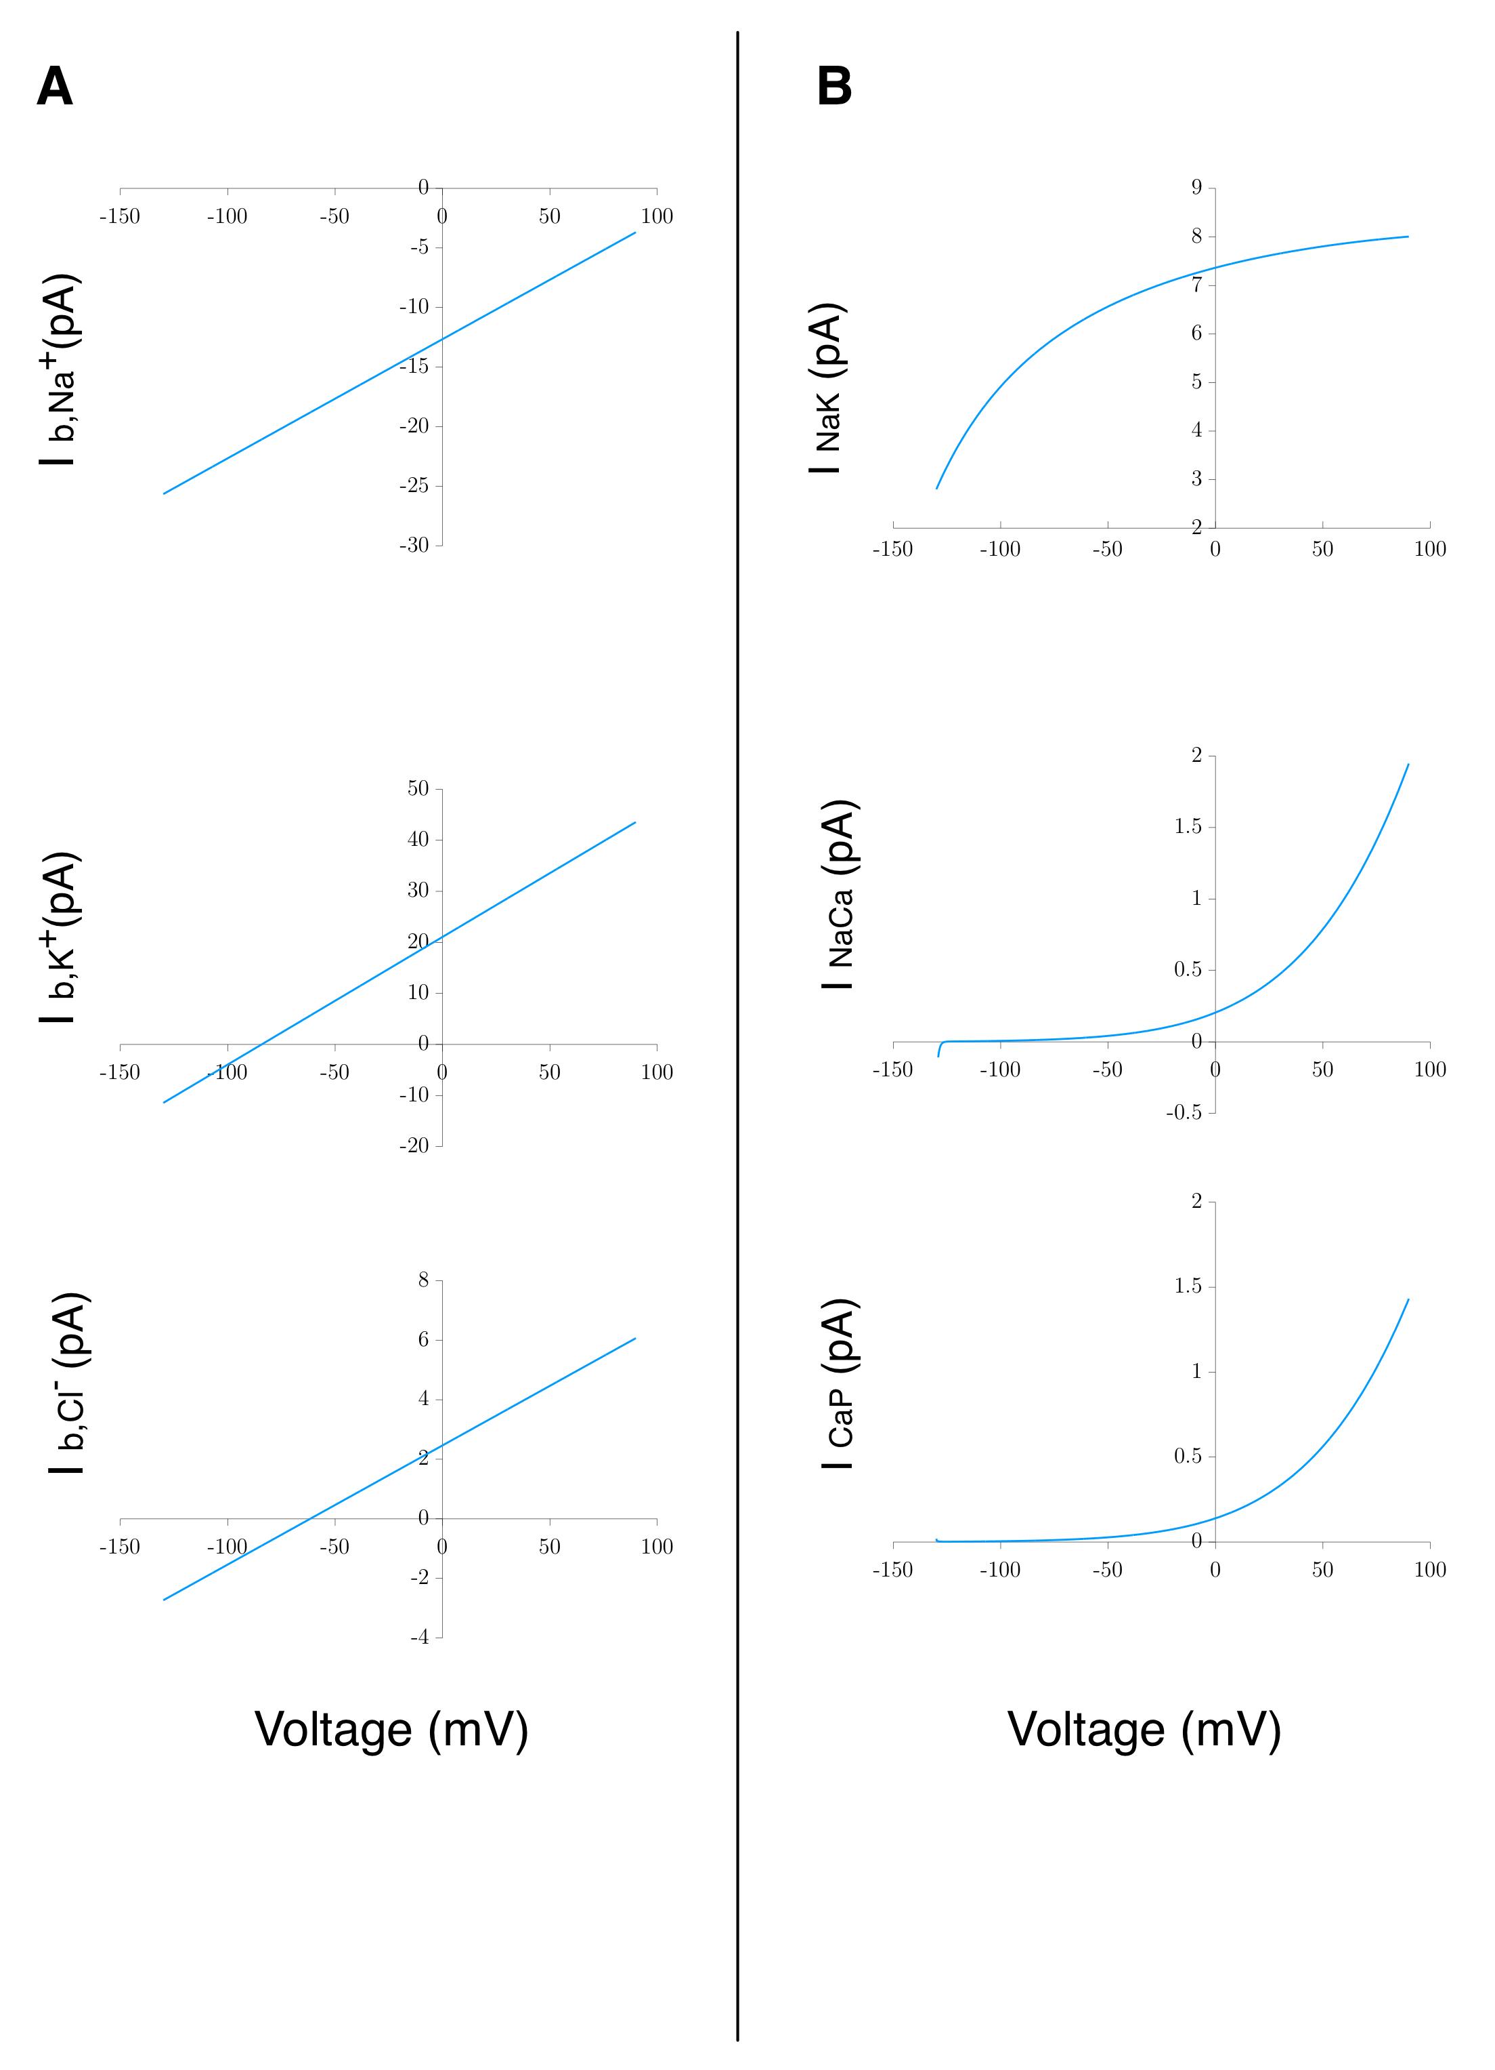

**Figure 3**

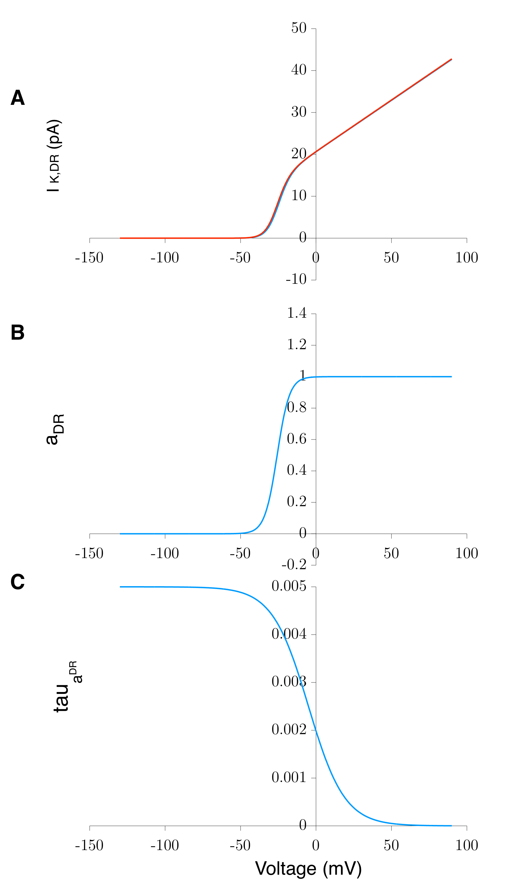

**Figure 4**

Experimental figure to be included. (?)

**Figure 5**

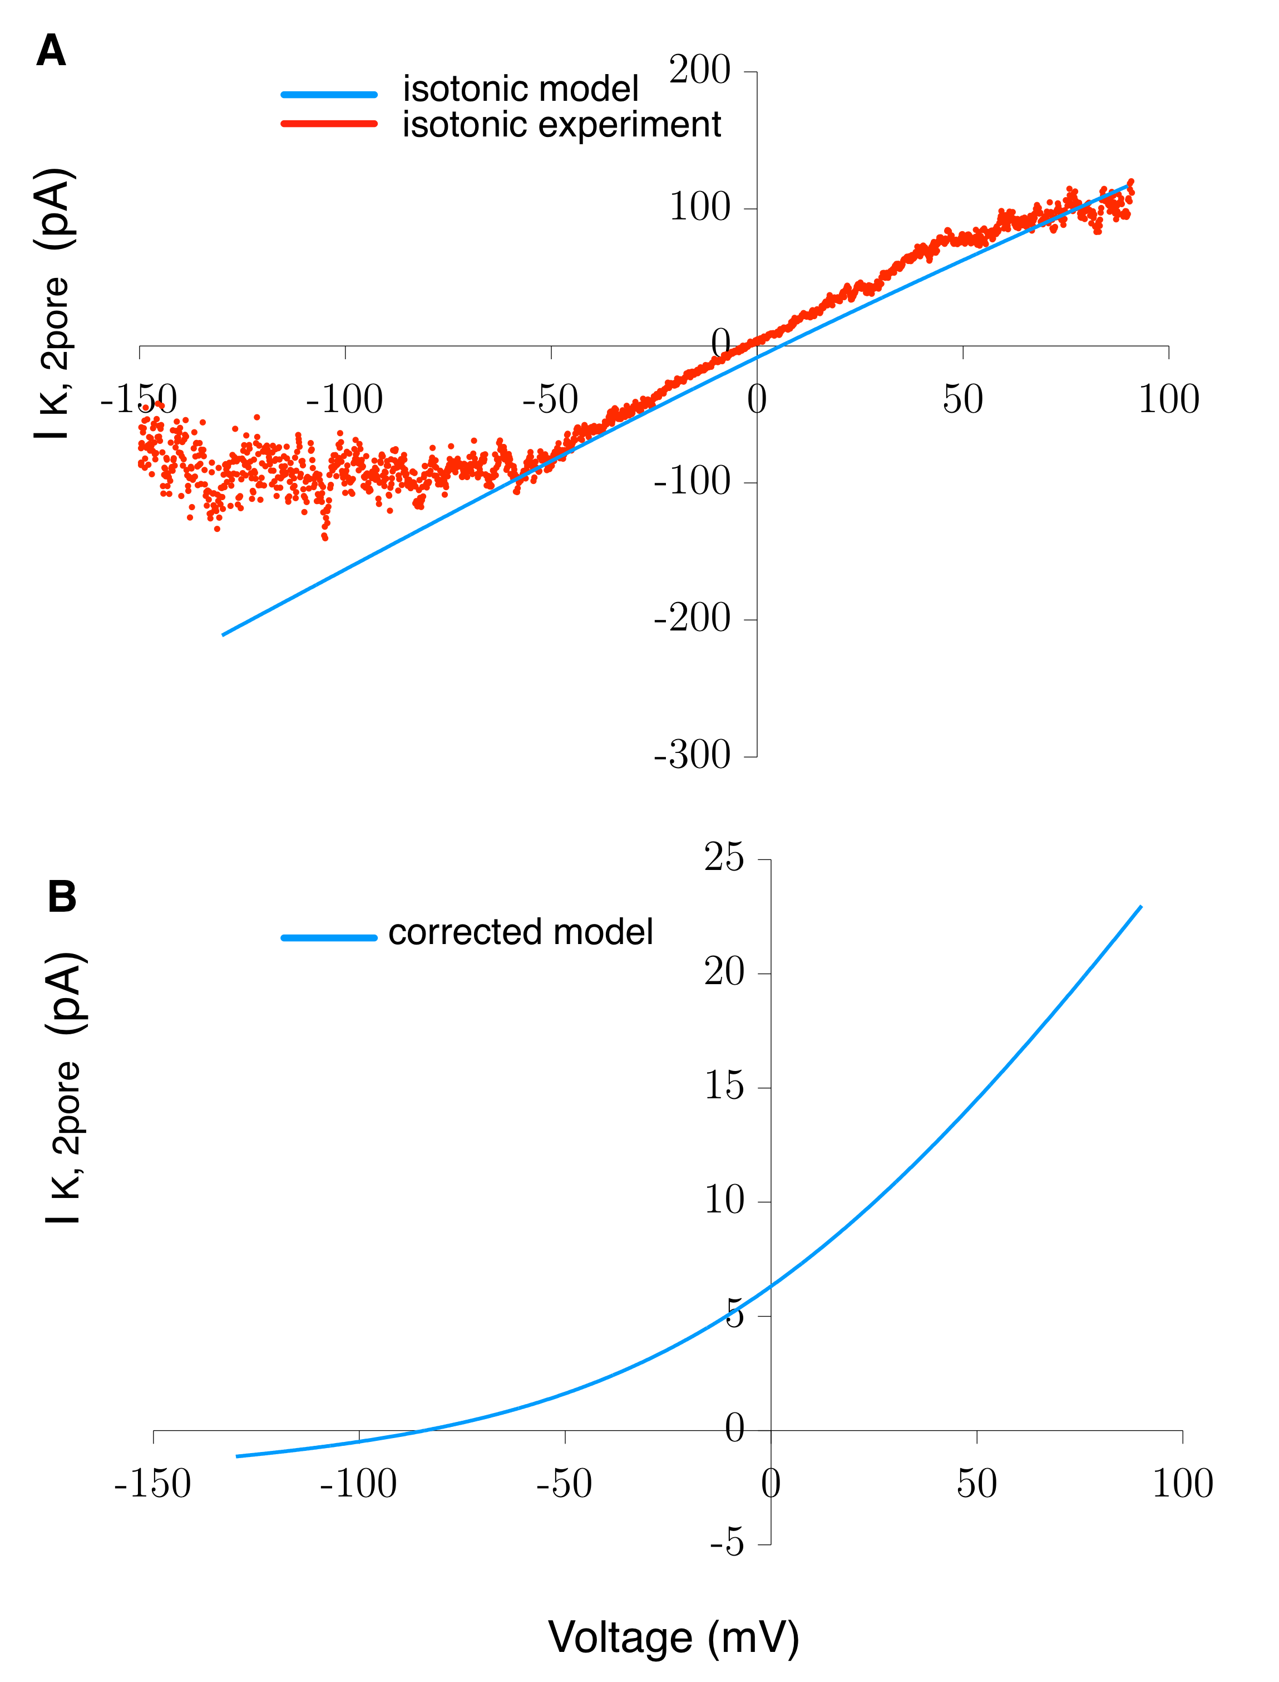

**Figure 6**

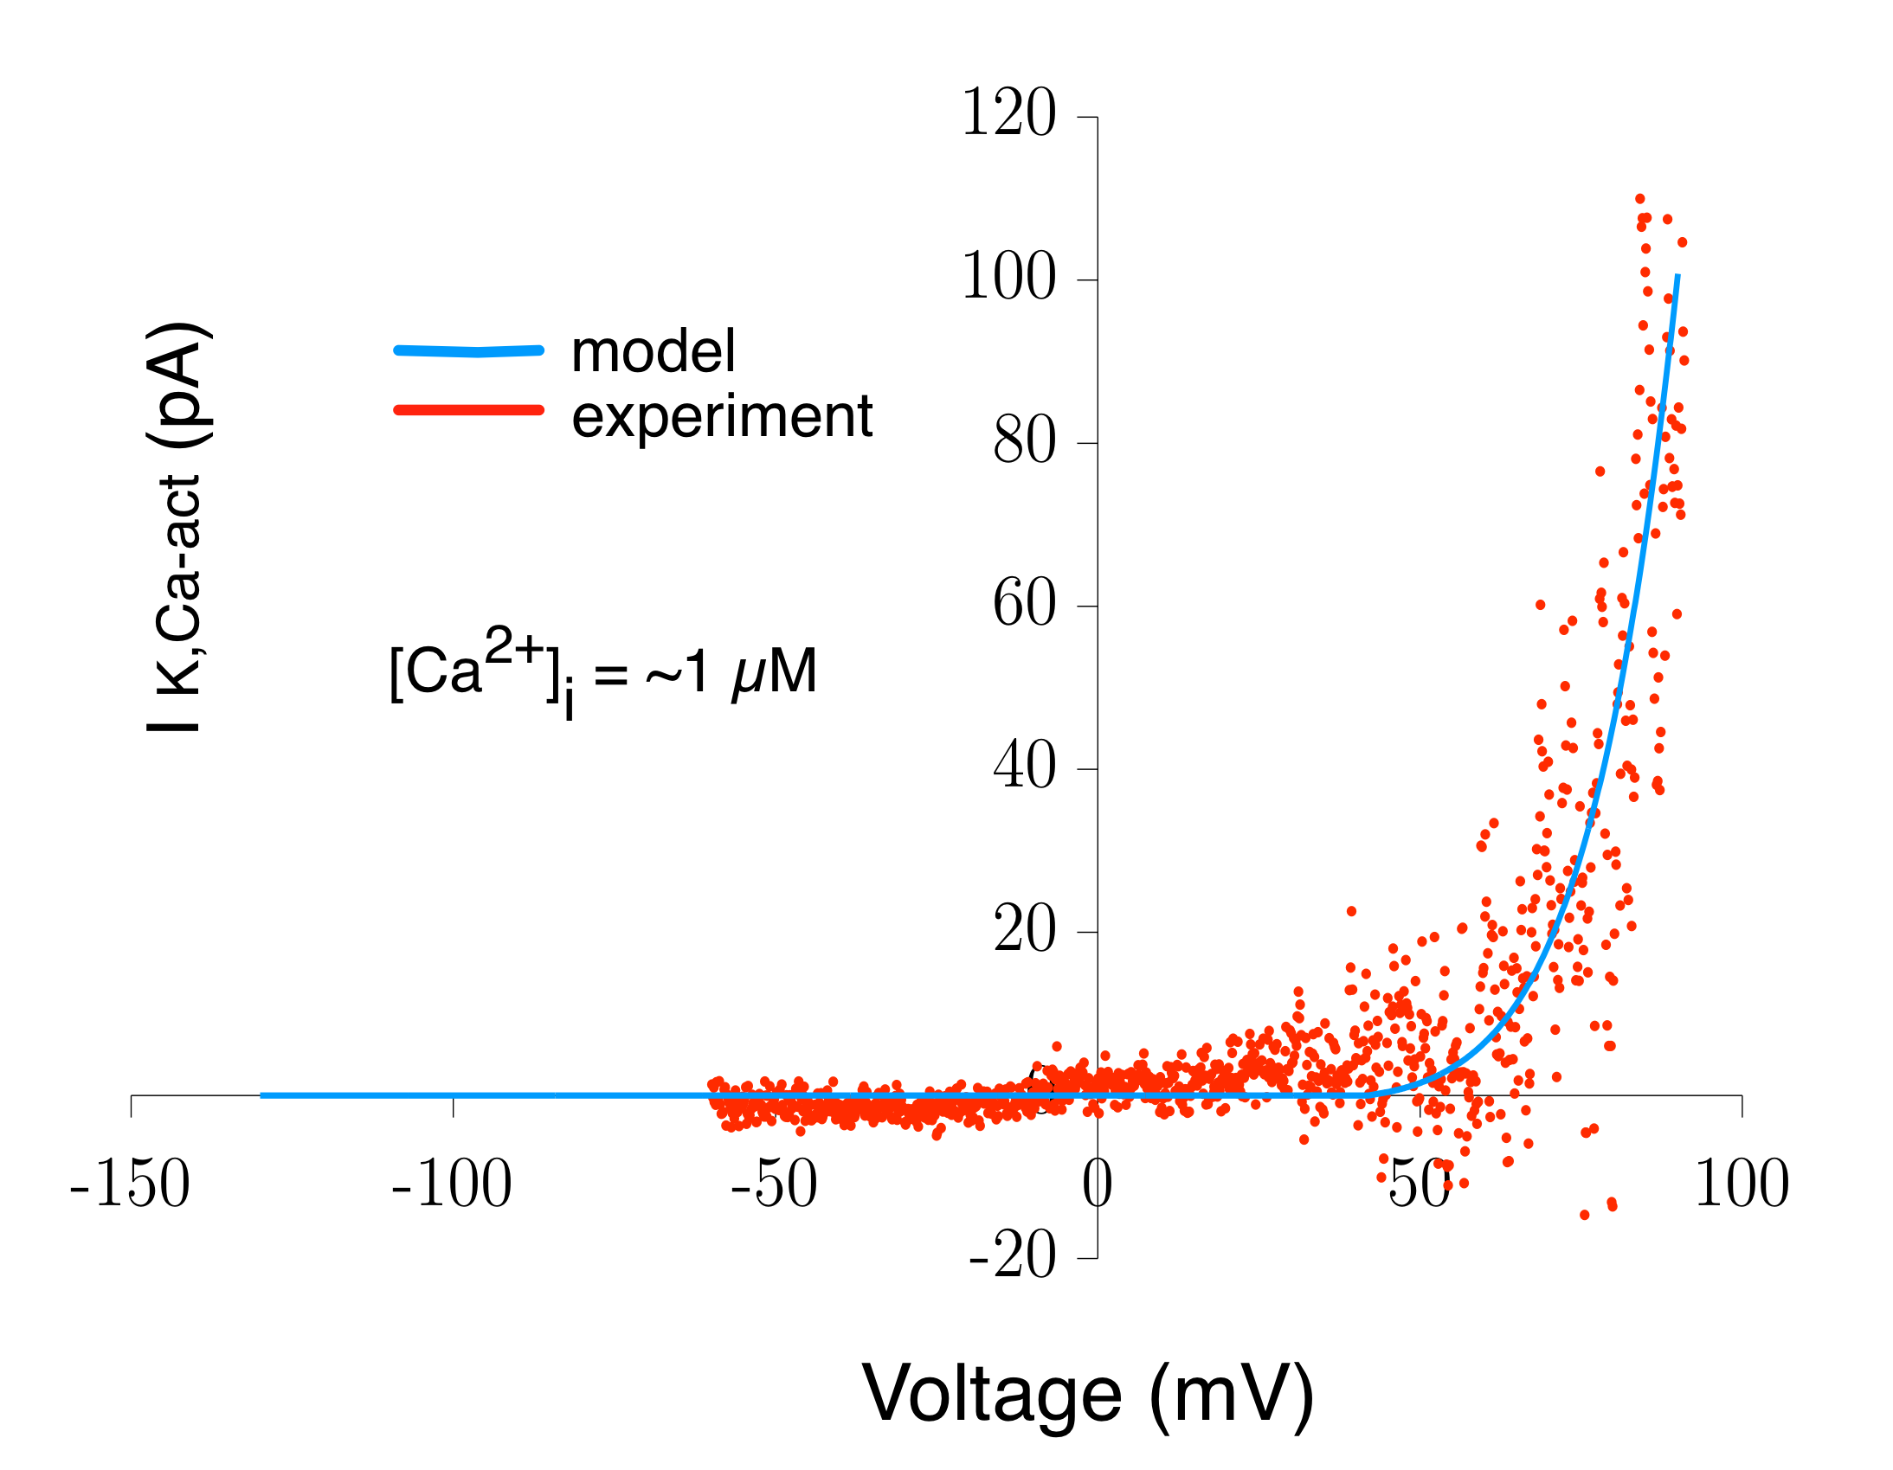

**Figure 7**

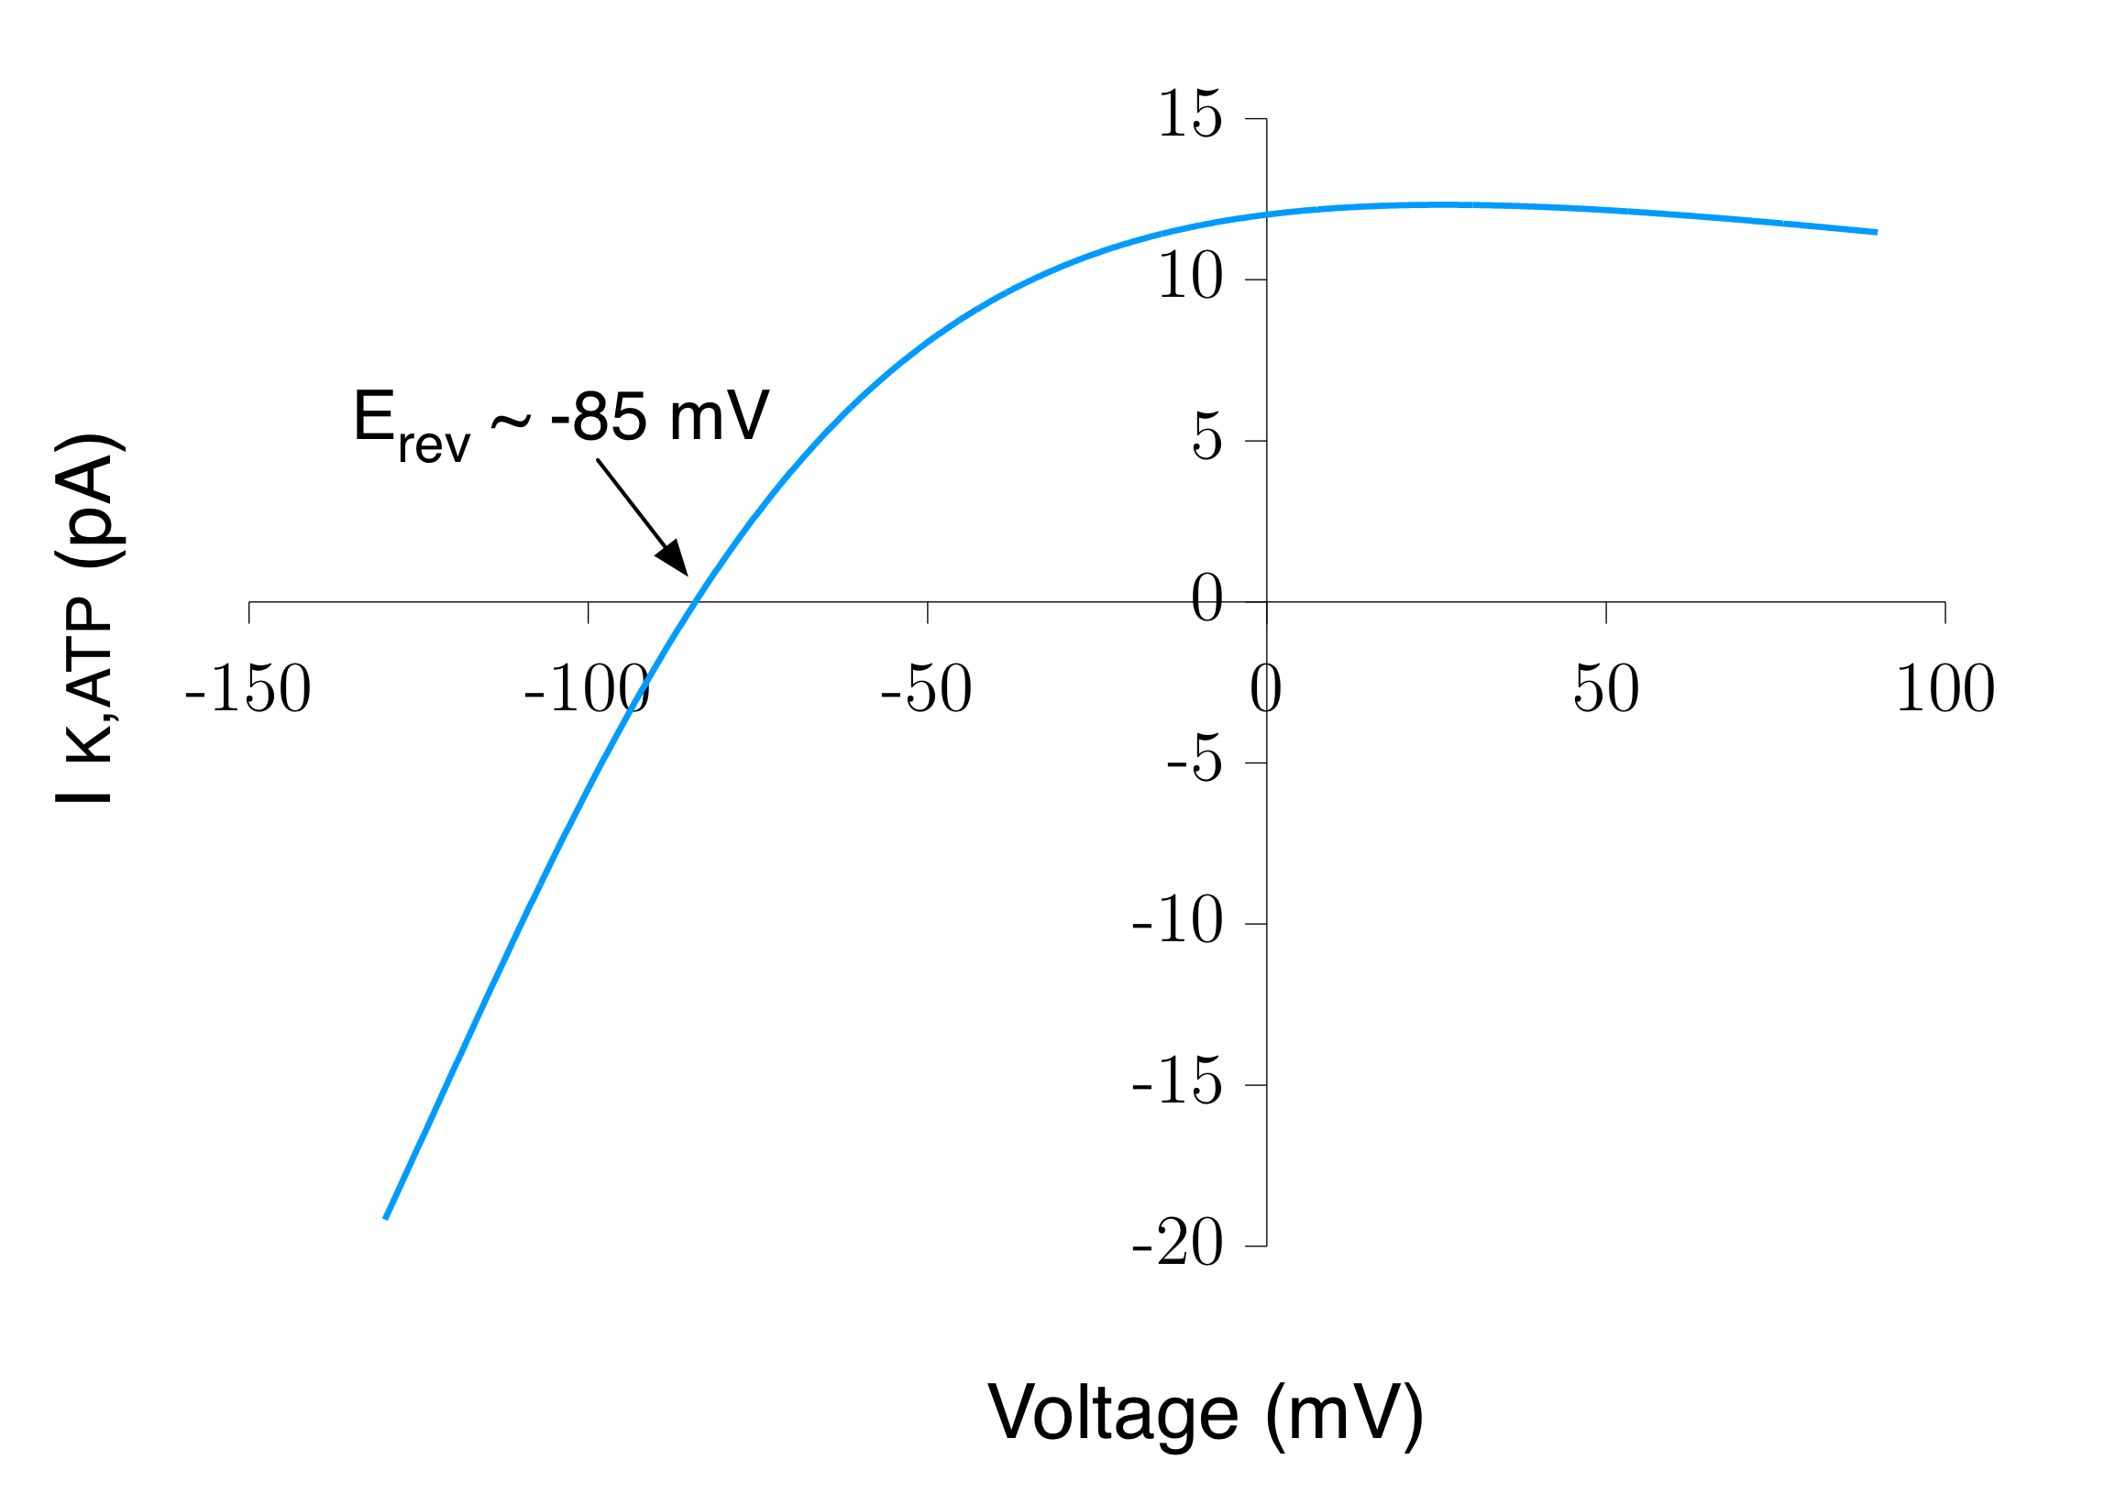

**Figure 8**

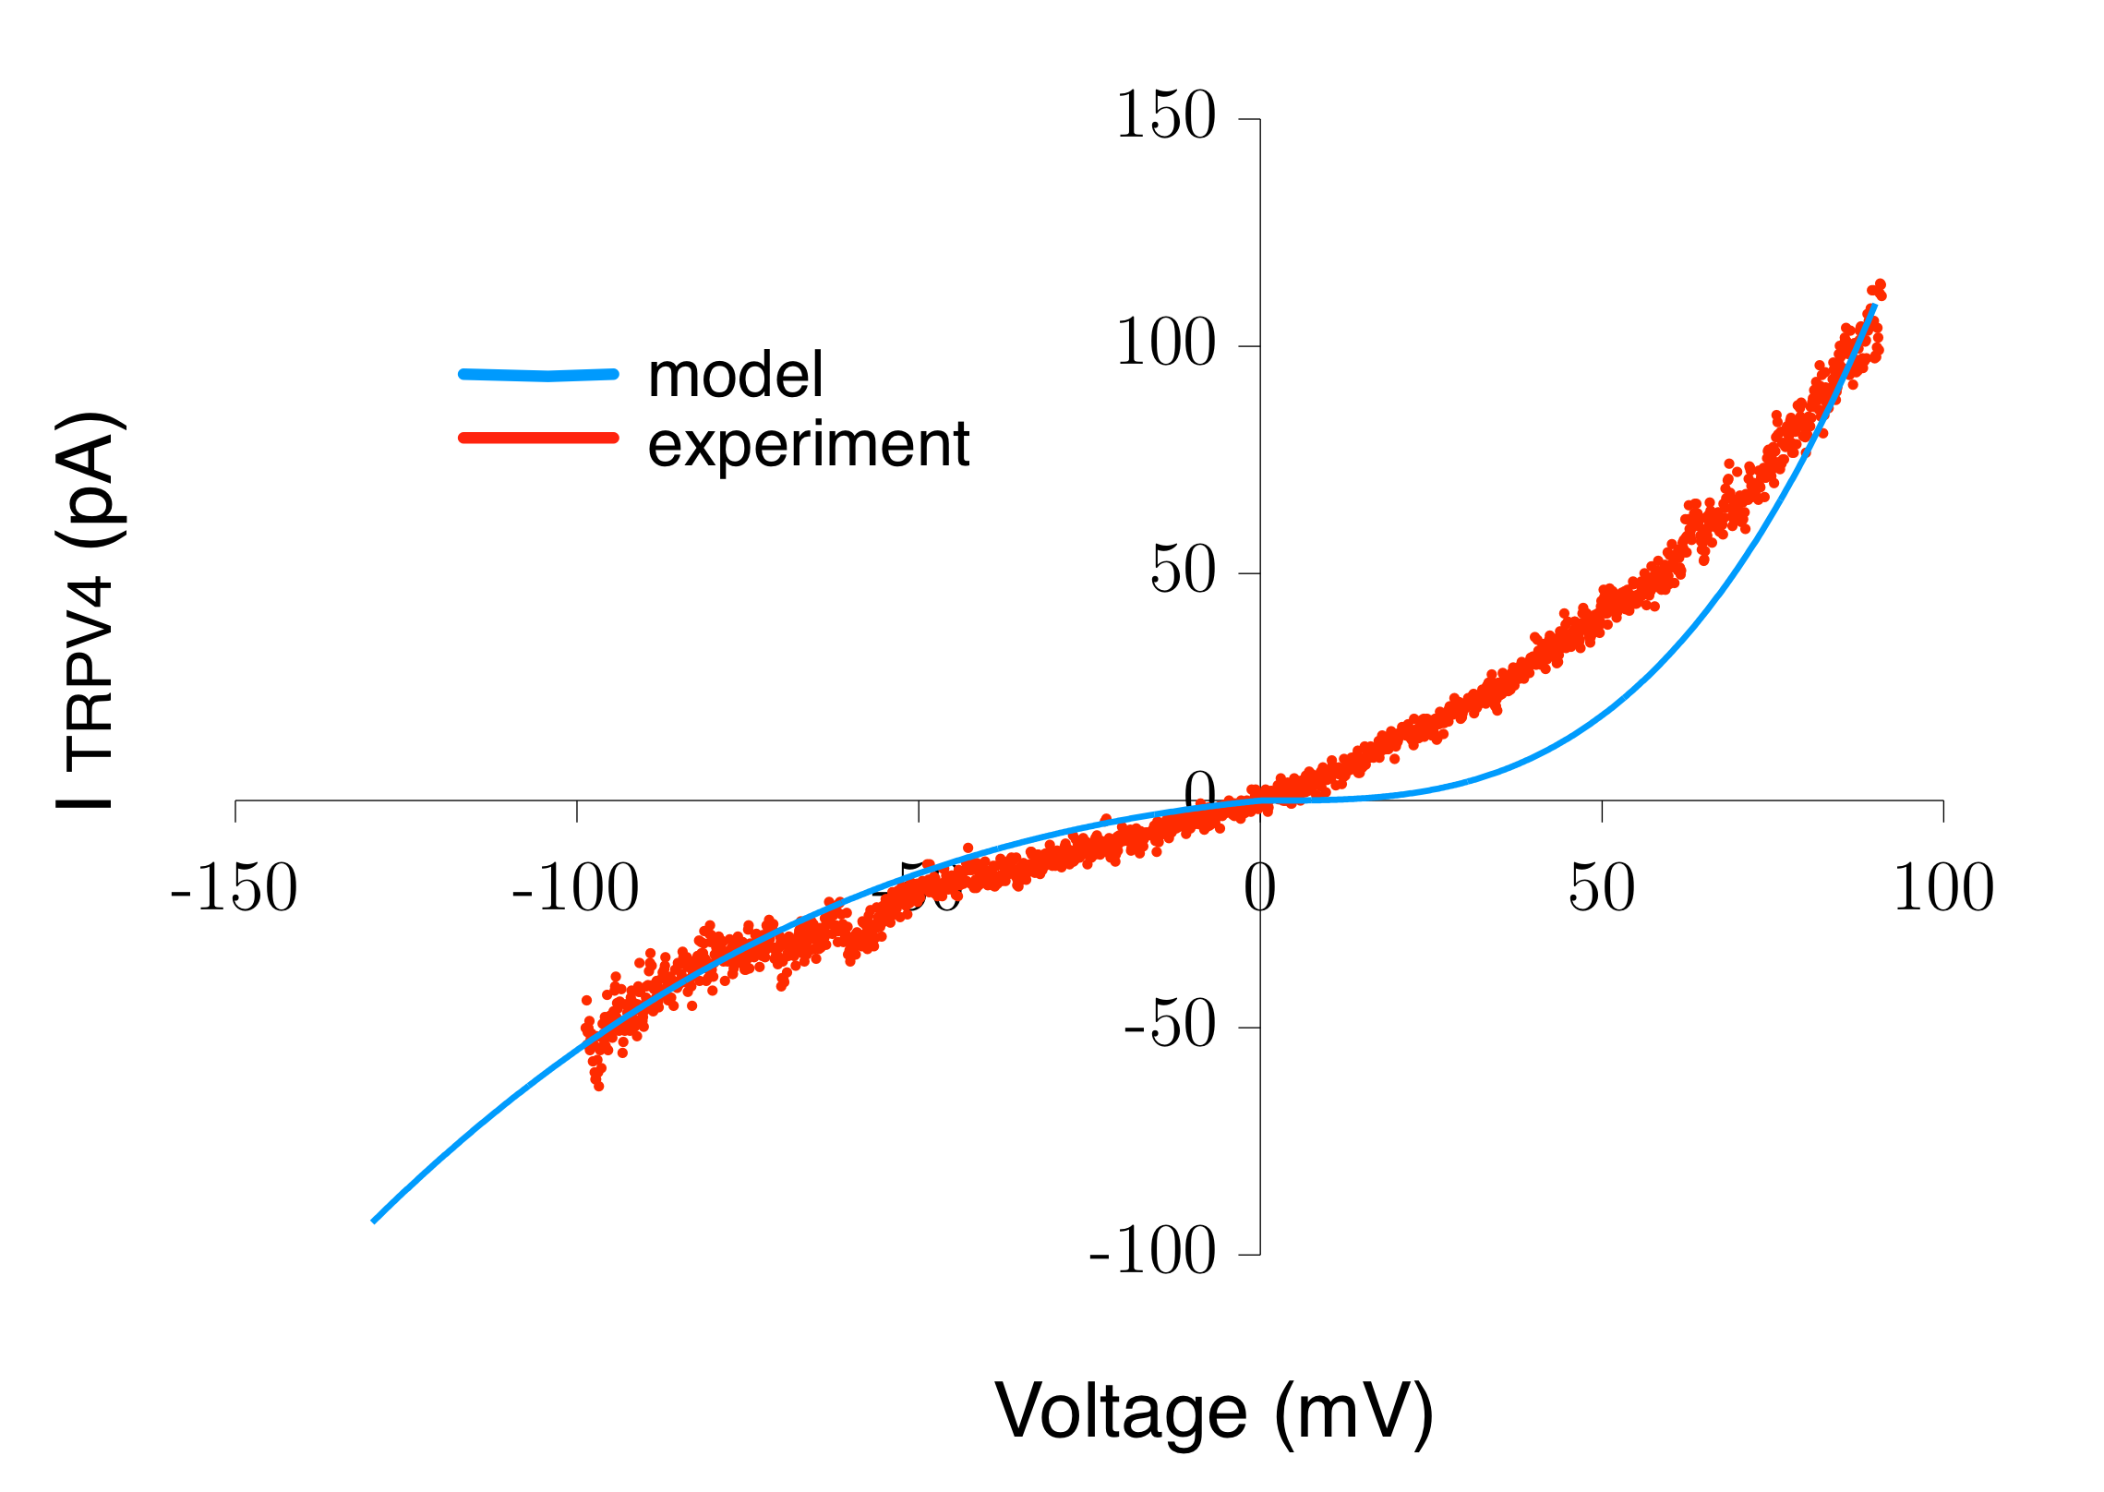

**Figure 9**

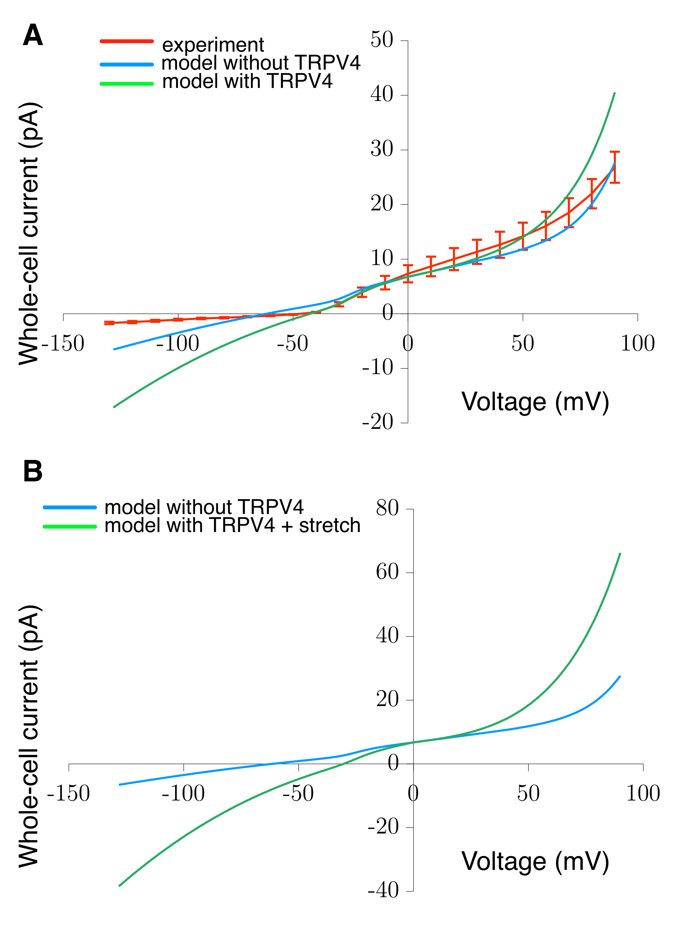

APPENDIX:

Model of seal resistance re: membrane potential